D 1.4.2 Public friendly annual report for publishing, including set of awareness tools

Slovak Safer Internet Centre III
(SK SIC III)

AGREEMENT No
INEA/CEF/ICT/A2014/0028

Dissemination level: PU
Nature of Deliverable: R

Since 2002 NGO eSlovensko is a long-term national leader within safer internet and new technologies issues. eSlovensko has professional educational experience disposing with branch know-how as the national operator of Slovak Safer Internet Centre since 2007 by running national awareness raising centre, operating Hotline and contributing to the operation of Helpline. Within 10 years eSlovensko established a system of regular quality training activities. It has proved sufficient knowledge and the ability to deal with safer internet issues by delivering Europe-wide successful online and offline tools and professional empowerment and other awareness raising educational activities with the impact in all regions of the Slovak Republic.
NGO Child Safety Line is a successor of the local branch of UNICEF, established in 1996 in Slovakia, helping vulnerable and endangered children, also within the cyber space and new technologies threats. Since 2004 Child Safety Line is the member of organization called Child Helpline International (the world-wide helpline network). Since 2008 it is also a member of another international organization called Missing Children Europe. Child Safety Line is the most important children’s rights advocate in the Slovak Republic. It operates the national Helpline, which stands already for 20 years as an integral part of the world of Slovak children. Its activities are based on the mission to protection, support and respect children's rights in accordance with the adopted Convention on the Rights of the Child.
The Ministry of Education, Science, Research and Sports of the Slovak Republic is the key national education-implementing body that operates the National programmes for modernisation of schools and schooling curriculum by using modern technologies and alternative forms of education. Increasing competitiveness within the use of new technologies, adaptation to current trends in the area including online child protection and support for their responsible behaviour have belonged to strategic objectives of MESRS SR within the Concept of informatics and informatization of school system (i.e. the process of involving IT tools into educational process and school system). Amongst other departments of the ministry there was a close cooperation with the Section of regional schools system responsible for prevention of social-pathological phenomenon including negative impacts of virtual space; the Division of regional education and National institute for education which continued incorporating issues of safer internet and responsible use of new technologies into school subject called Informatics with SK SIC providing the teaching material; the Methodical-pedagogic Centre, a subordinate organisation of the ministry, focusing on pressure on continuous conceptual learning of pedagogical, non-pedagogical as well as the learning of workers with youth to prepare them adequately for spreading the prevention activities among children and youth (awareness raising activities); the Research Institute for Child Psychology and Patopsychology in the field of research activities focused on the behaviour of children and youth on the internet. The dissemination and distribution of materials elaborated and published by SK SIC were provided through regional school bureaus net. MESRS SR ensured dissemination of information and SK SIC centre’s outputs on safe and responsible use of new technologies and appropriate prevention of negative issues in virtual space.
Slovak Safer Internet Centre (SK SIC) consists of three components: Awareness centre (Zodpovedne.sk; Responsibly in Slovak language), Helpline (Pomoc.sk; Help in Slovak language) and Hotline (Stopline.sk). The philosophy of SK SIC is reflected in the graphic message, which resembles a child’s hand, as well as the World Wide Web symbol and colours intend to evoke the traffic lights analogy. The green represents the green light for responsible use of internet and modern technologies. Orange stands for the helping hand (“be careful and watch out - once there has anything happened to you or just might happen, we are here to help). Red light symbolises the stop sign for illegal content and conduct in the virtual space (online illegal child sexual abuse material etc. SK SIC continuously implements the goals and aims of previous Safer internet Programme, Safer internet Plus Programme and ongoing Connecting Europe Facility (CEF) in Telecom. SK SIC contribute to the best-practices on European and global level. SK SIC is also very active in the legislation process concerning the safer internet issues. SK SIC has so far received 27 awards proving of outstanding reach of activities and tools delivered.
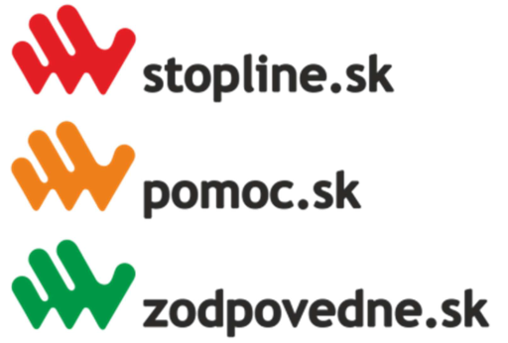

Key milestones
- since 2002 involved within the eCrime and eSafety issues in Slovakia
- since 2008 the member of the Council of the government of the Slovak republic for the prevention of the Crime
- 2009 launched globally successful and multiply awarded project OVCE (Sheeplive) - the website is complementary to the Sheeplive cartoons with lots of informative and entertaining content for children. Cartoons are available altogether in 25 languages, version in sign language and audio-commentary (for deaf, blind, visually-impaired).
- 2010 signed agreement with LEA (Police force) under the Ministry of Interior of the Slovak republic
- 2010 formal Command of the President of Police Force of Slovak republic regarding the Release of annual plan of main tasks (Article 5 within the activities of police force paragraph. 1 In the field of crime prevention by the letter b) ensuring tight cooperation with eSlovensko on projects Zodpovedne.sk and Stopline.sk operational work
- collaboration with the Ministry of Interior of the Slovak republic on the elaboration of the Strategy of the prevention of the crime 2012-2015
- currently participating within the home affairs projects in partnership with the Ministry of Education of the Slovak republic
- since 2013 eSlovensko is the national coordinator of the campaign No hate speech movement under the authority of the Council of Europe
- 2013 the book Children in the web (dedicated to the teachers, parents, suitable for beginners and also experienced professionals, explaining basic terms with the stress on the risks)
- 2014 launched the project Nehejtuj (DoNotHate, the issues of intolerance such as the discrimination, xenophobia, bullying, home violence, etc. 12 professional movies and 80-pages professional book with further project information available at project website nehejtuj.sk)
- 2015 launched the project Kybersikanovanie (Cyberbullying) - the kit contains professional book and the best movies following cyberbullying issues, available also at kybersikanovanie.sk
- 2015/2016 launched the movie of RYTMUS – a dream from the block
- 2016 Who’s next (feature film on risks of internet follows in the line of previous SK SIC projects)
- 2016 eAddiction (first European application mapping phenomenon of addiction on increased usage of internet with emphasis on prevention was the main focus within the covered period)

1. AWARENESS CENTRE
SK SIC undertakes to operate an awareness centre for informing and empowering children and youth (including children and youth at risk as described further), parents, teachers, social workers, care-takers about better and safer use of the internet, building on enhanced digital resource centres (repositories).
Accordingly with the Work Programme 2015:
- Devise informative awareness campaigns and resources targeting children, parents, grandparents, care-takers, teachers and social workers on how to give children the digital skills and tools they need to take advantage of the Internet and to navigate safely online, promote awareness of parents and children on online quality content and experiences, and make the associated resources available through their services.
- Engage with children and young people from different demographic groups by setting up a youth platform, including organising regular youth participation activities, allowing them to express their views and pool their knowledge and experiences of using online technologies.
- Evaluate the impact of the awareness campaigns on the target groups and provide qualitative and quantitative feedback at European level through the core service platform.
- Establish and maintain partnerships and promote dialogue and exchange of information with key players (government agencies, ISPs, industries, user organisations, education stakeholders) at national level.

Multimedia knowledge library (MKL)
MKL has been well established within the ongoing project of SK SIC throughout the development and dissemination of professional multimedia tools across entire Slovakia, but also in European and global context (books, researches, dictionaries, comics, films and cartoons, documentaries etc.). Media tools are essential in grabbing the attention of target groups through the emotions. The success and the proof of the outstanding SK SIC results and impact among the target groups throughout media tools has been brought by the project Ovce.sk (Sheeplive.eu) and in cinemas recently projected movie called Rytmus – A dream from the block, that in weeks become 4th most successful movie in history of Slovak cinematography (the movie hits the topic of hate speech and Rome minority intolerance).
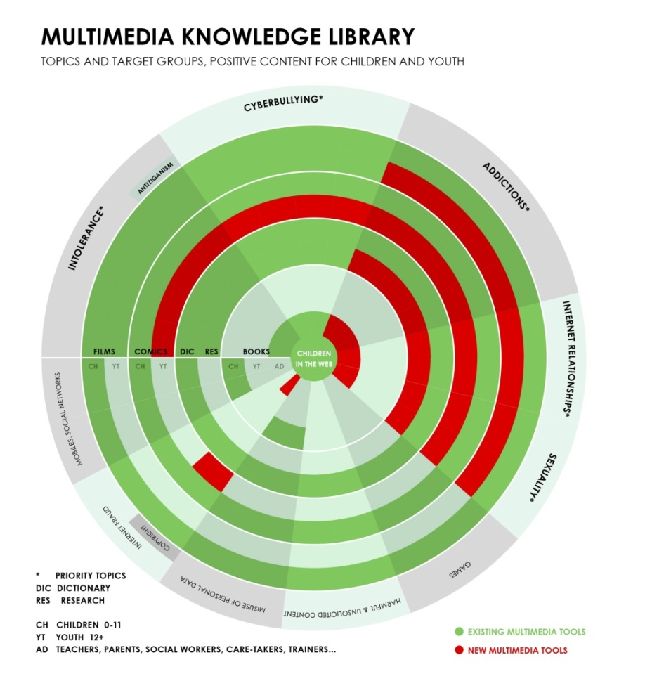

As for the structure of MKL, SK SIC have so far within the years 2007-2016 aimed its projects and tools at the primary prevention while working with target groups. Recently we realised that this prevention part is almost fulfilled and it is essential to more likely maintain particular knowledge, skills and habits. The other way around, we are aware that it is crucial to move towards secondary (also called “selective”) prevention where main emphasis is be given on target groups that are already in risk (dealing with particular threat) while identifying children and youth in danger to accordingly provide them with necessary help. Thus SK SIC decided to complement solely the comics No problemos into thoe primary prevention area while aiming the rest of the activities and projects into the secondary prevention. Additionally as the outcome of whole process, we intend to use gained knowledge (quantitative and qualitative results) while developing new tools and projects back in primary prevention.
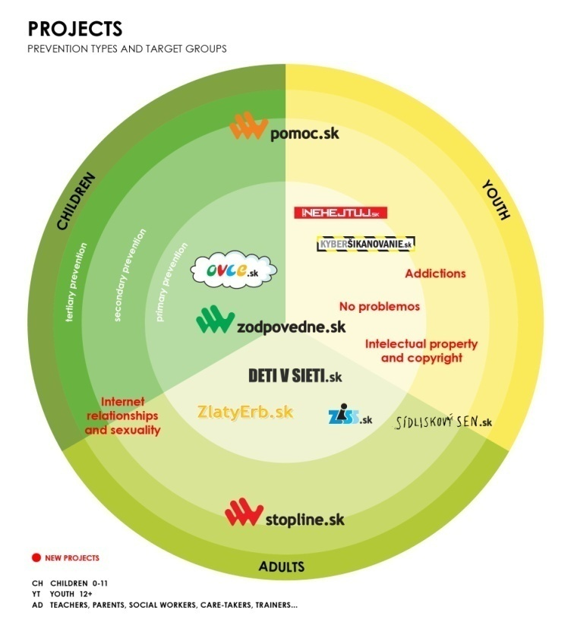
MKL target groups are designed as a children in the age of 0-11 and youth 12+ (including children in social and health risk, i.e. visually-impaired and blind, hearing-impaired and deaf, etc.) and also adults (teachers, parents, social workers, care-takers and trainers). SK SIC intentionally aims to help improving the daily life of as wide span of Slovak citizens as possible while supporting economic growth.

Children and youth at risk
For furthe emphasis transition from the primary to secondary prevention it is essential to pay dedicated attention to children and youth in various risks. This target group includes socially excluded children and youth including four biggest national minorities in Slovakia same as children and youth excluded based on health issues. SK SIC is alread focusing on visually-impaired, blind, hearing-impaired, deaf and other children and youth with impairments (disabilities) targeted with dedicated tools and activities. The SK SIC workes with socially excluded children and children at risk through cooperation with the kids in kindergartens, primary and elementary schools as well as re-education centers, prisons, children’s homes.
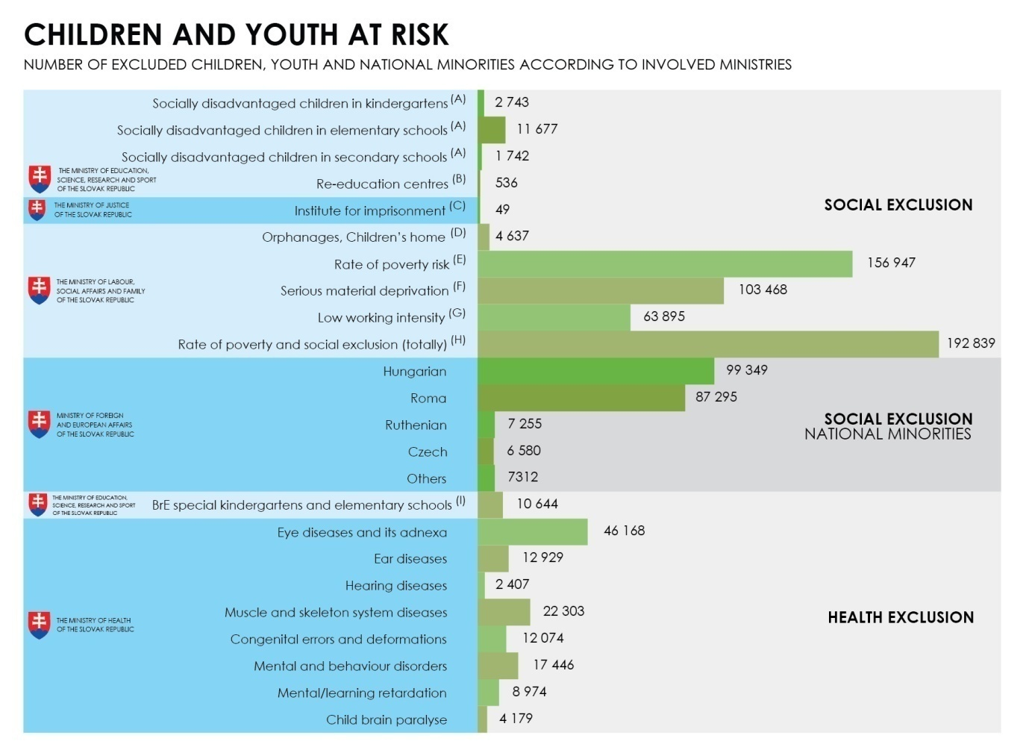
Training activities
One of the main tasks of the consortium partner the Ministry of Education is to implement Action activities into the system of formal education in kindergartens, elementary and secondary schools or special schools in Slovakia attended by totally 1,1million of children and youth. MKL tools are this way successively implemented and projected into official school tools (Sheeplive project as a part of the book Informatics at elementary schools, the book Children in the web also used as an official teaching book). The primary education in terms of training is covered by the schools while SK SIC acts as a complementary training partner with its rather informal approach.
With the reference to above mentioned, SK SIC intends to focus mainly on secondary prevention while addressing target groups of children and youth at risk, health and socially excluded children and youth as well as national minorities. Regarding the target groups of adults, SK SIC put emphasis on professionals and specialized employees from social, health and education resorts (social workers, care- takers, etc.) as well as psychologists, doctors, teachers, priests (Silesians, Catholics, etc.) police-men etc. Training activities will involve representatives from various demographic groups.
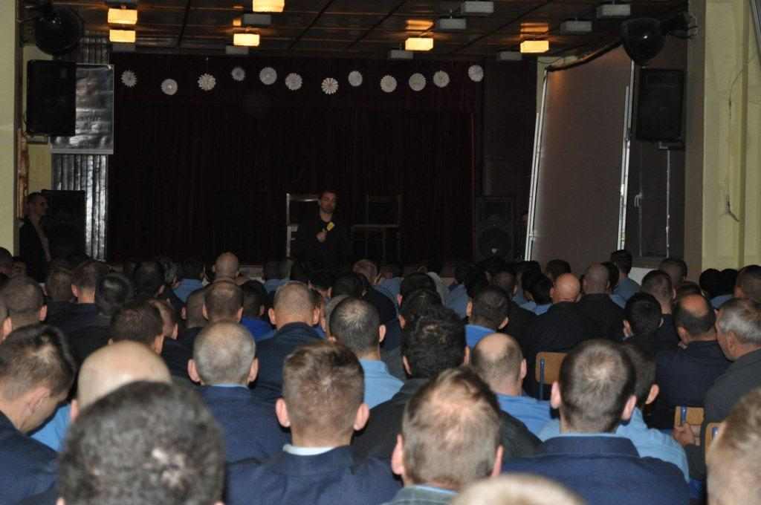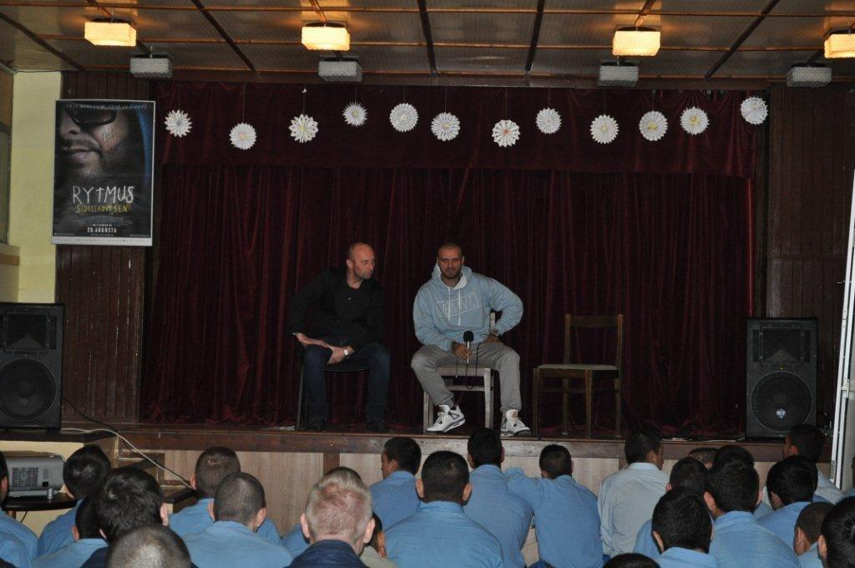

European and international contribution
The closest cooperation is that with the CZ SIC due to historical reasons, similar problems in the society and proximity of the languages.
The SK SIC has been active contributor to the European networks of which it is a member, i.e. Insafe and INHOPE. They were key for successful cooperation and know-how / best-practices exchange in the international ambiance. In the covered period SK SIC representatives participated at the following events:
- Insafe – Prague 05/2015, Warsaw 12/2015 and Larnaca 04/2016
- INHOPE – Haag 06/2015, Lisbon 11/2015 and Copenhagen 05/2016
- International events – Hradec Kralove 4/2015, Lyon 6/2015, Luxembourg 10/2015, Lyon 10/2015, Lyon 5/2016, New Dhilli 5/2016, Brno 5/2016, Barcelona 7/2016, Dublin 6/2016, Cieszyn 5/2016

MKL was originally designed to contribute on European and international level through adapted professional tools as demonstrated in the info-graphic.
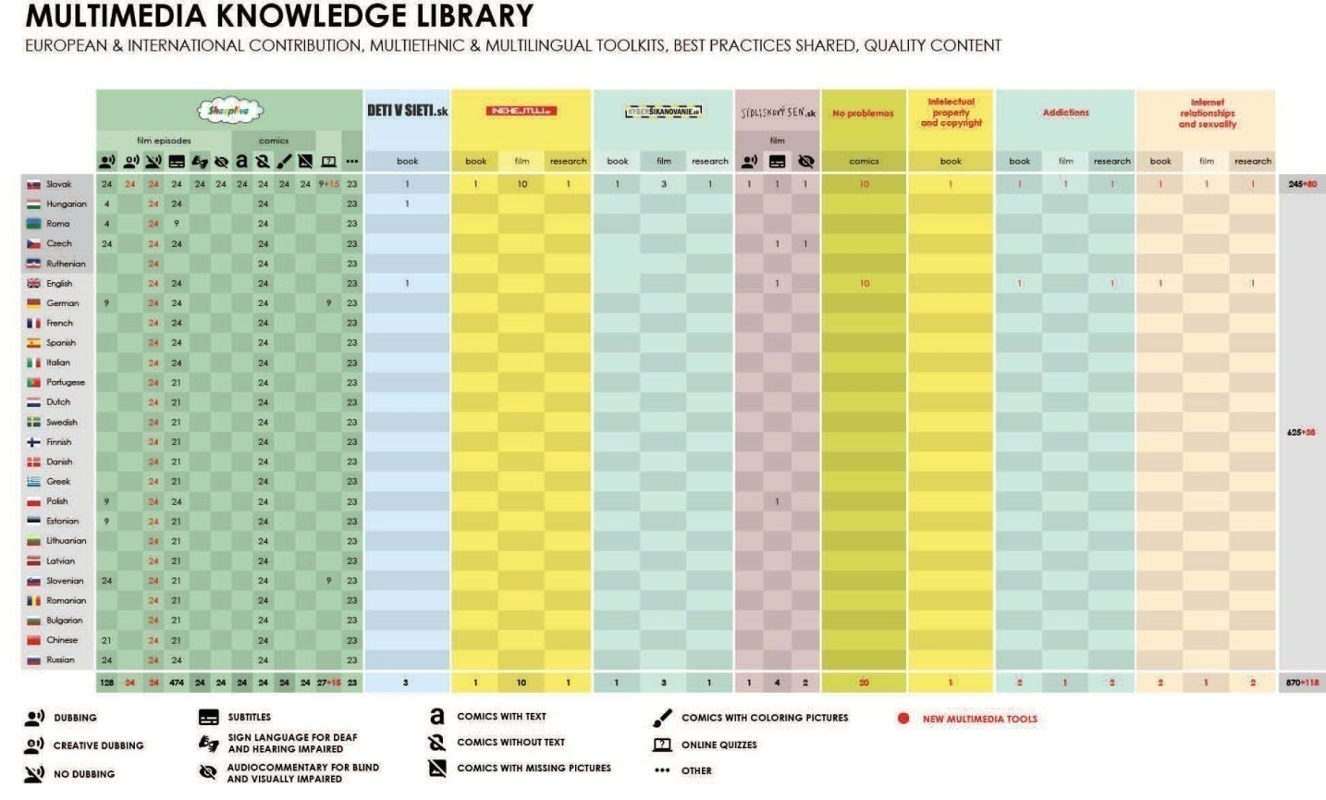
The SK SIC continued to build its MKL which was shared with its international partners. It was enlarged through cooperation with numerous organisations as follows:

Sheeplive.eu
The cartoons were disseminated to Czech Republic’s television channels and to Poland, where Polish dubbing was added and 9 new cartoons were disseminated in cooperation with the PL SIC. Talks with Child Focus – SIC Brussell (BE) started on dubbing into French and Dutch. Cooperation with a Slovenian partner resulted in joint dubbing and dissemination of 24 cartoons in Slovenia. SK SIC commenced discussions with a Serbian organisation on dubbing and dissemination. 3 new episodes were subtitled into English and screened at Hiroshima International Animation Festival (JP) in 2015. In 2016 they were delivered to India through Delegation of the European Union to India.
Kybersikanovanie.sk (Cyberbullying)
Audiovisual part of the project draw from cooperation with Childnet (UK), National Association for Prevention of Child Abuse and Neglect (AU) and Rally to Delete Digital Drama campaign (USA) and expert text was inspired by other SICs material. The material was promoted in Ireland (Cyber Safe Ireland).

Rytmus Dream from the Block
When producing the film Rytmus Dream from the Block the following partners were involved: Kroměříž Hospital (CZ), City Hall of Přerov (CZ), Himalayan TV Channel Delhi MLA (IN), Delhi Police, Uttar Pradesh Police (IN), Slovak Embassy to India (IN), Warner Music Czech Republic (CZ), Falcon (CZ), Kino na granici (PL). Cooperation was established with the Delegation of the European Union to India when the film was screened at the EU Film Festival in India from May to August 2016 in 11 Indian cities.

Let’s fight together
The Slovak language version of the subsection related for the film http://digizen.org/resources/cyberbullying/films/slovak/lfit-film.aspx. The Slovak version is one of the only 7 languages in which the film is available. The film was also dubbed in the Slovak language.

Intellectual property rights (online)
When building up the multimedia knowledge library with the issue of intellectual property rights, the SK SIC cooperated with the European Union Intellectual Property Office (EUIPO) which provided supervision of the activities related to the issue which later on developed into partnership based consultancy.

Data protection
In cooperation with the Representation of the European Commission and the Slovak Data Protection Office the SK SIC prepared an educational material for students on personal data protection online.
eAddiction
During desk research phase which entailed gathering expert opinions and experience of other partners, the SK SIC persued cooperation with the University of Barcelona (ES) and University of Brno (CZ).

Hate speech
When dealing with hate speech online, intensive cooperation was established with Facebook (USA) and their representatives in Ireland. Through working on monitoring and reporting extremist material online the SK SIC cooperated with Jugendschutz (DE). Joint, so far informal cooperation was established with SafeLine (GR).

Children in the web
A publication on risks in the virtual environment was prepared in cooperation with the No Hate campaign of the National Committee of the Council of Europe. The book has been disseminated online and offline to adults, parents, teachers and people working with children.

Cyber Crime
Cooperation focused on exchange of experience and capacity building in the topic of cyber crime was established with UCD Centre for Cybersecurity and Cybercrime Investrigation (IRL) and ISSS (CZ).

Who’s next?
During development of the film we established cooperation with Russia (audiovisual material), Warner Chappel (USA), Entrada Interactive (USA).

Web Rangers
Within the initiative Web Rangers the SK SIC cooperates with Google in order to promote digital literacy among the youth. The aim is to promote and educate the youth about how the internet is an empowering tool relevant to their lives and their futures.
Youth Platfrom (YP)
YP is national empowerment network of young representatives used as an advisory body on SI issues. Young people from national YP will contribute to effective project implementation by expressing their views and sharing their knowledge/experience about online technologies issues. YP will help the activities and tools within the project to be tailor made to address the needs of the young people, to get initial feedback from the platform on the already implemented activities and to follow the trends in the age group of teens. YP is national structure of 4 key regional parts of the country formed with about 8-12 members each and regular meetings. During the platform meetings methodology of focus groups is being used, together with brainstorming, structured and moderated discussion.
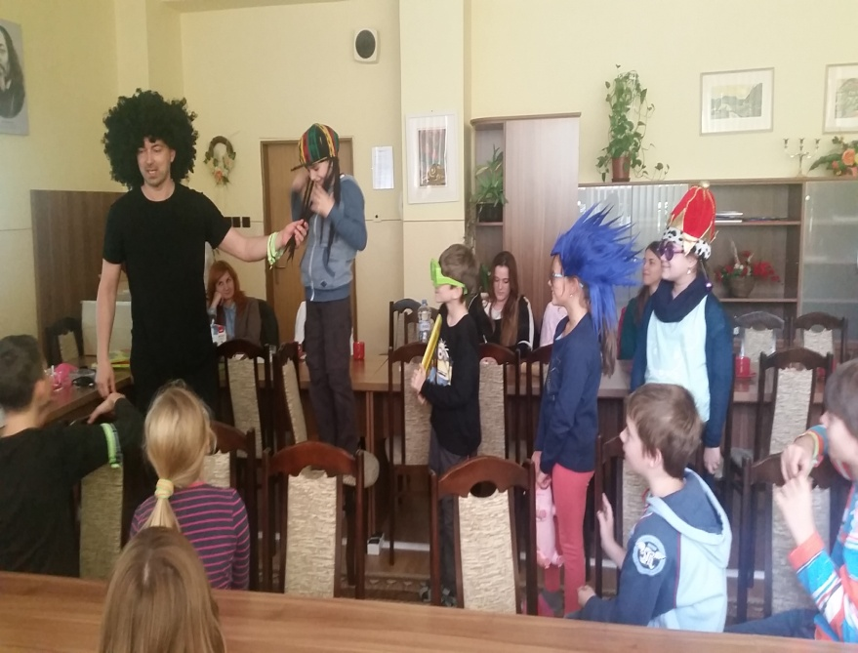

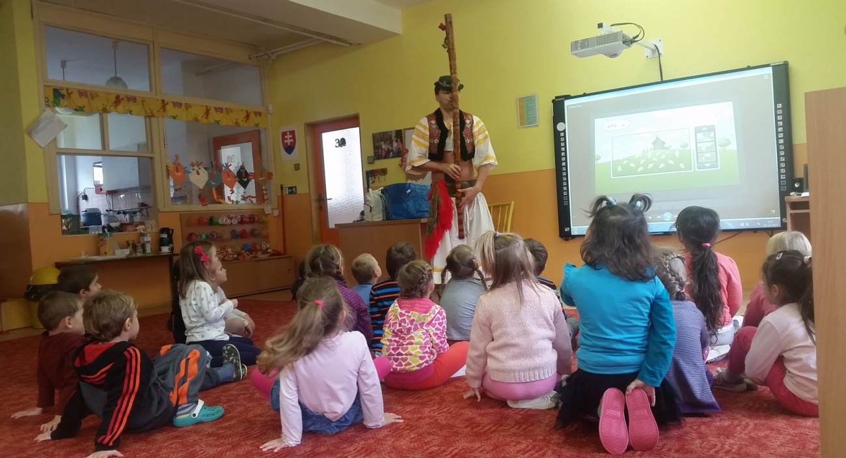

Key tools and projects
Cyberbullying (Kybersikanovanie.sk)
Both online and offline awareness raising tools were used during the campaign aiming to spread knowledge on cyberbullying, sensitivise on cyberbullying, change passive witnesses to active defenders of victims and help understand feelings and emotions of victims, aggressors and witnesses. The kit contains a 116-page book on cyberbullying, DVD with 6 films. The website offers introduction in the basic terminology, films, basic principles on how to spot cyberbullying, legislation dealing with the issue, how to report it, examples from Slovak schools, information and news from workshops, order form and contacts. The book contains also a workbook for teachers and social workers working with the youth.

eAddiction (neZavislost.sk)
It contains online tools mostly. Development of the first European application mapping phenomenon of addiction on increased usage of internet with emphasis on prevention was the main focus within the covered period. The project is designed for mobile and internet users who can use an android based application with informative, prevention and therapeutic goals. It helps towards self knowledge and finding balance between online and offline time. It will also be useful for professionals and experts whose applied research will bring information on risks, social factors and predisposition to addiction and addictive behavior of users. Project is beneficial for psychiatrists, psychotherapists, psychologists, school psychologists, special educators, social therapists, social workers and others. Wide public who can benefit from internet website neZavislost.sk with useful information, recommendations and professional help. Together with awareness raising campaign the project helps parents, families, schools, state institutions, private and third sector or media understand the up-to-date phenomenon of eAddiction. Outputs of the project eAddiction will be mobile application, internet website, awareness raising campaign, research and consultancy. There are plans to establish a Slovak Center for Internet Addiction. Launch of the application is foreseen for the SID 2017.

Sheeplive.eu (Ovce.sk)
Slovak cartoons for kids on risks of internet and mobile devices offered through the website and a kit containing DVD and book. The website is complementary to the Sheeplive cartoons with lots of informative and entertaining content for children. Apart from the videos it offers a handful of accompanying features, such as games, cartoons, glossary, emoticons and many downloadable items. The SK SIC has produced Sheeplive cartoons not only in Slovak, but also in Hungarian and Roma, languages of the largest national minorities in Slovakia. There is also a version in sign language and version with audio-commentary for blind and visually-impaired audience. In cooperation with other partners either dubbing or subtitles was produced for Poland, Czech Republic, Russia, China, Slovenia, altogether in 25 languages.

NoProblemos.sk
Series of 15 comics informing youth about societal challenges of today through humour and attractive creative form of comics prods young people to see the chosen topics in new circumstances. NoProblemos.sk deals with issues of intellectual property rights, hate speech, xenophobia. The outputs of the projects include website, print of individual stories in 3 issues of the most selling teenage magazine Kamarát and other secondary school fanzines. 6 posters (one per comics) were advertised all over Slovakia in a chain of 25 bookstores. Online campaign consisted of newsletters being sent to partners in Slovakia, online publishing of comics on teen web pages www.referáty.sk, superbrigáda.sk, zones.sk and launch of new created webpage www.noproblemos.sk where all the comics can be found in one place.

Having wits (Mať filipa.sk)
Campaign aiming to support the prevention and fight counterfeiting and piracy mostly online with focus on youth. A web page www.matfilipa.sk in the Slovak language was produced. It is the only website that brings the information on both intellectual property rights (industrial and copyright). Slovak students and teachers can for the first time find on one place verified and highly topical information about IP. The content is based on a new Slovak Copyright Law which has come into effect as of 1 January 2016, was confirmed and authorized by the Slovak Patent Office (ÚPV SR). The webpage contains descriptions and definitions of the IP terms, image examples of these definitions, definitions and links to the IP offices and agencies, link to a NoProblemos comics web page, book Mať filipa to download or order and Frequently Asked Questions to download. A 94-page book Mať filipa on IP topics, written in the Slovak language was printed. The prints are being distributed to secondary schools and teachers who cover IP topics (art schools, technical and industry schools).

Do not hate (Nehejtuj.sk)
Both online and offline tools of Nehejtuj.sk (or Do not hate in the Slovak language) follows intolerance issues. Nehejtuj.sk consists of the web portal and kit including double DVD with 12 professional movies and 86-page book. It is aimed at raising awareness of issues of discrimination, xenophobia, bullying and domestic violence. The website includes the tools (videos, book) dealing with intolerance and online hate speech on the internet with the goal to raise awareness of the issues.

Rytmus Dream from the block (Rytmus Sídliskový sen)
It is a feature-length documentary film about the most famous Slovak music star RYTMUS (rapper and singer). The documentary reveals complexity of relationships within families and racism in Slovakia. Family had been then facing racism for 37 years while struggling for love in its core. After 8 years of shooting this documentary this “Gypsy” raised by “whitey´s” became self made ikon amongst youth and music celebrity releasing multiple platinum albums. The search of his Roma roots made him to be interested in the Roma culture, made him try to find out his real Roma father who left him as a child when he was 4 years old, and even want to visit comunity of Dóms in nort-west India. Cinema goers saw the film which gained many awards within first couple months such as for the biggest attendance of the movie on the premiere day in the entire history of Slovak cinematography, 2nd biggest attendance of the movie on the premiere weekend in the entire history of Slovak cinematography, 4th most successful Slovak movie in Slovakia ever and 4th most successful Slovak movie in the Czech Republic.

Who’s next (Kto bude ďalší?)
A feature film on risks of internet, it follows in the line of the previous projects - Cookie.sk, educational television series (2008, 9 parts, 15 min.), educational animated series Sheeplive.eu (2009-2012, 24 parts, 3 min.), both dealing with internet safety and full-length documentary Rytmus Dream from the Block (2015, 80 min.) about the meaning of life, family issues and racism. The film will have the form of an educational and prevention oriented episodic film in a duration of approximately 90 minutes. It will deal with cyber-bullying and effects of internet on young people. Other topics will depict danger of using mobiles when driving, selfie related injuries and deaths, sexual exploitation, eAddictions and livestreams. Each of the episodes will cover a different danger that cyber world entails. Age suitability will be set for 12+, picture cinemascope, colour (24 fsp), sound 5+1, Dolby Digital. Première is envisaged in 2018.

SK SIC in-house events
Safer Internet Day 2015
In February 2015 the SK SIC at its own costs joined the Safer Internet Day and launched the multimedia project Cyberbullying (Kyberšikanovanie.sk) which is the first multimedia project in Slovakia aiming at prevention and working with children through short films from abroad dubbed in the Slovak language, book with worksheets of 25 activities for pedagogical workers and books.

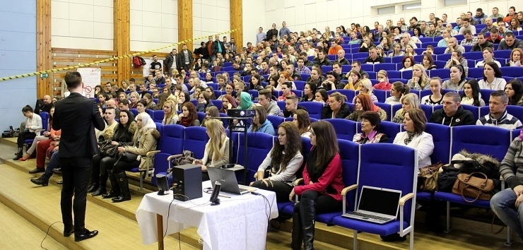
Launch of the Cyberbullying (Kyberšikanovanie.sk) campaign

Let´s read 2015
Helpline number 116 111 is promoted through this event each year in June. Regional and school libraries across Slovakia participate at this event. In 2015 June 38 383 kids and youth took part in the event. During the event they also use SK SIC tools. Each participant was given a bookmark with the reference to the Helpline number 116 111 and SK SIC.
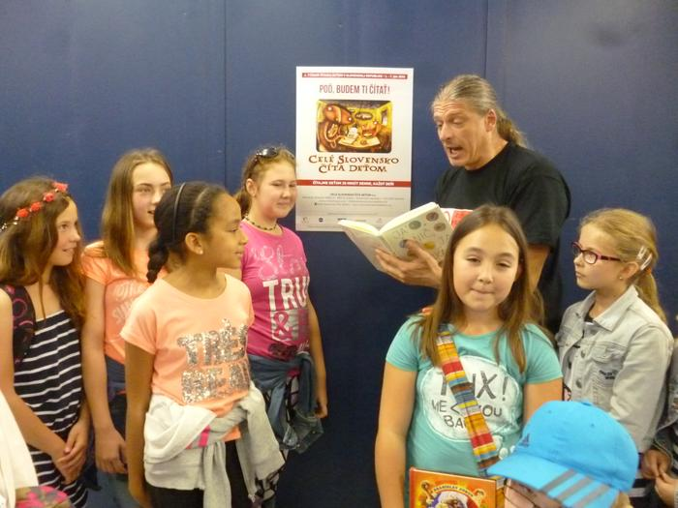
Popular Slovak writer Brano Jobus reading to children during Let’s read on 7 June 2015 in Piestany

Première of Rytmus Dream from the Block
The first night of the film was on 20 August 2015. It was organised in one of the most popular cinemas in Bratislava, Aupark where hundreds of cinema viewers watched it.
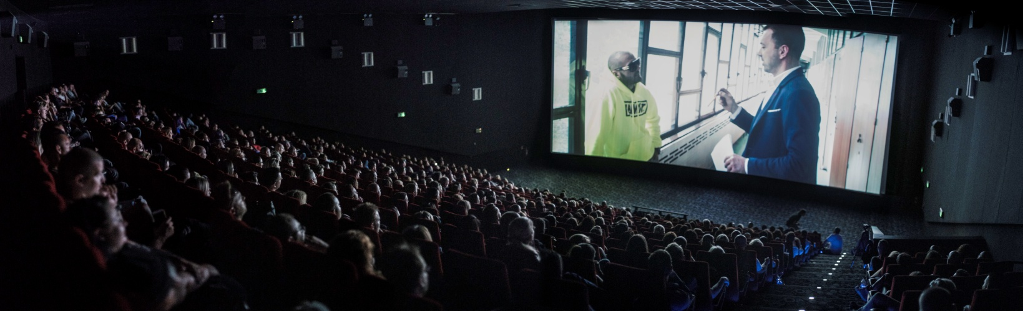
Première of Rytmus Dream from the Block on 20 August 2015

21 km run 2015
The charity run organised by SK SIC annually attended by 100 children and key Slovak media to support SK SIC visibility. The awareness section has been dedicated to children and parents through SK SIC poster presentation, educational leaflets, providing individual information and counselling consultations. The event welcomed 129 runners.
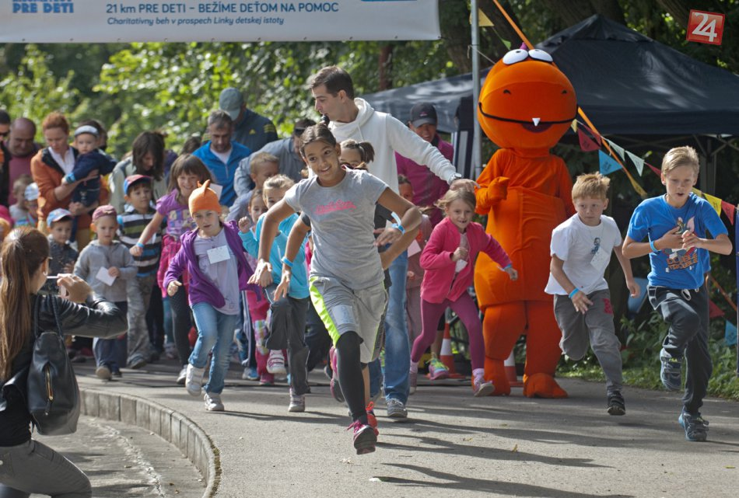
Youth actively participating at the 21 km run on 6 September 2015
Zlatý Erb Competition, ITAPA Conference 4 November 2015, Bratislava
The Zlatý Erb (Golden Crest) was awarded to local self-governments for best websites. Role of the competition is to recognize outstanding projects that promote the exchange of experiences and evaluate efforts of representatives of local governments to use information and communication technologies to improve the quality and accessibility of self-governing regions, towns, boroughs and municipalities. The winner of Grand Prix is automatically nominated to the international competition Eurocrest. The milieu – ITAPA conference was chosen on purpose as IT leaders and top level managers participate at the conference.
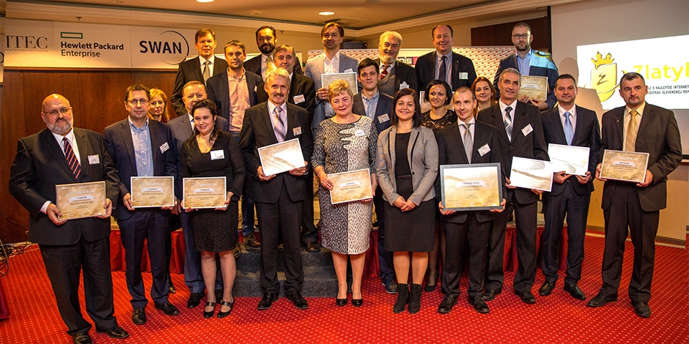
Winners of the 2015 Golden Crest

Safer Inter Day February 2016
On Safer Internet Day the SK SIC launched a series of workshops which included screening of the film Rytmus Dream from the Block and motivational lectures for youth across the country. The main theme was hate speech online and message was how not to become a target of hate speech online. Lectures were attended by experts and the rapper himself as a popular figure for the youth attracting their attention. The rapper warned that the virtual world brings with it risks of anyone exposed to a danger of becoming a target of online. Other experts provided information on how to deal with trolls, or how internet portals deal with a breach of the rules. The events aimed at students of secondary schools, orphanages and re-education centers. A series involved screening and discussions in Sučany, Bratislava, Nitra, Žilina, Košice and Bratislava (for north west districts).
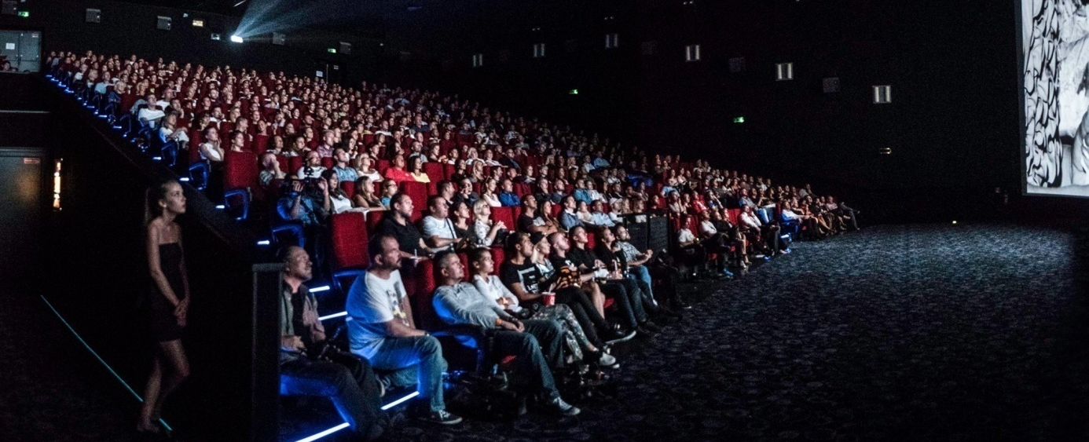
Screening of Rytmus Dream from the Block and discussions on hate speech online during SID 2016

Let´s read 2016
Helpline number 116 111 was promoted via promotion of reading throughout the month of June. Regional and school libraries across Slovakia participate at this event. In 2016 June 40 954 children from 237 towns and villages were involved. During the event they also use SK SIC tools. Each participant was given a bookmark with the reference to the Helpline number 116 111 and SK SIC.
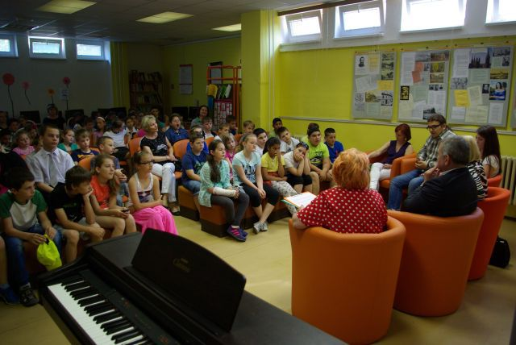
Mayor of town of Michalovce at the launch of the event in a local library, 3 June 2016
Launch of the book Mať Filipa, Bratislava 22 June 2016
A launch of the book explaining both industrial property rights and copyrights took place at the Secondary Grammar School of Juraj Hronec in Bratislava. An ambassador of the idea, architect Tomáš Žáček, author of Ecocapsule installed in the European Council building in Brussels provided valuable information to students on how to protect their intellectual property rights online.
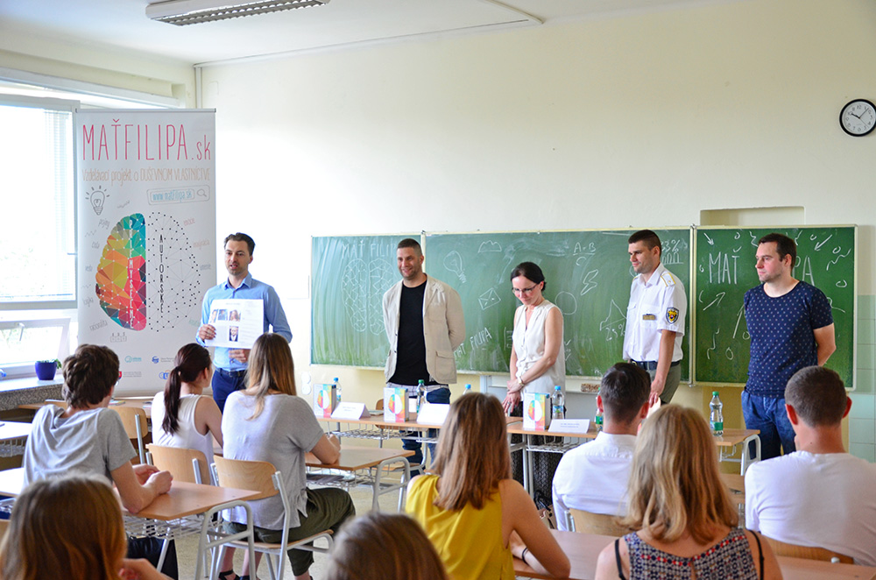
Representatives of SK SIC together with Slovak Patent Office and Customs Office representatives at the launch of the book
Other stakeholders’ event
On Extremism without Extreme, Bratislava, Jun 16 June 2016
No Hate Meeting, Ministry of Education, Science, Research and Sports of the Slovak Republic, Bratislava Jun 2016
SOS 3 – Life Rescue Units and Children (3rd year of prevention and presentation event), Michalovce 10 June 2016
Child Hepline for Tolerance Conference, Bratislava 16 December 2015
Usmev ako dar (Charity event Smile as a Gift) Bratislava, 5 December 2015
Web Rangers, 14 October 2015
Safety Day, Bratislava, 5 September 2015
3rd Year of Child Firefighter Competition, Rojkov, 25 July 2015
Workshop on history of Czech-Slovak comics, BRAK Festival, 30 May 2015
Conference Metro On Line 2015, Poprad 13 May 2015
A mile for Mum, Bratislava, May 2015
Workshop on Cybersafety, Ministry of Health of the Slovak Republic, Bratislava, 27 April 2015

Amongst other events it is necessary to mention our partner’s activities towards awareness raising on child welfare. Child Safety Line worked towards drawing attention of adults to their roles and responsibilities in raising children in a world where the media and virtual environments become immediate part of the whole society.
The partner used the opportunity to meet with adults - teachers, parents, doctors, psychologists, school-based prevention workers in prevention and psychology centres and together with them looked for areas to help create relationships of children in the virtual world and promote safe use of new technologies. They created a space for the exchange of ideas and experiences in finding optimal conditions of child protection in a virtual environment.
Within the project "Strengthening the tools to integrate children in decision-making processes in schools" (Banská Štiavnica district) Child Safety Line participated at a three-day training for teachers focusing on children and secure virtual world. Many topics were selected according to actual situation addressed in subsequent meetings.
Child Safety Line met with the entire teaching staff in Zvolen, Martin, at several schools in Bratislava. In Banska Bystrica cooperation was established with catechists of Banska Bystrica diocese.
At the national medical conference "Preventive medicine in the context of today" a panel with information about the Child Safety Line and dangers of new technologies was installed. Opportunity to disseminate information about the safe use of cyberspace was established through working with traffic playgrounds Junior.
Child Safety Line was a co-organizer of the International Interdisciplinary Conference on socio-pathological phenomena among children and young people (SPAY 2016 - Social Pathology Among Youth), in March 2016. Presentations dealt with bullying in a virtual world, children's participation, child-oriented approach. The conference was co-organized by the University of St. Elizabeth in Bratislava together with the Ministry of Interior, SKCH, Office of WHO, the Pan-European University, NGO Prima, Health Initiatives Association Agreement, and other partners from the Czech Republic, Hungary, Poland, Austria and the UK.

National cooperation
The national cooperation involved working with stakeholders throughout the various layers of the society, be it state administration, public organizations, private sector and other non-governmental organization either responsible for the issues of SK SIC scope of interest or working in those areas.
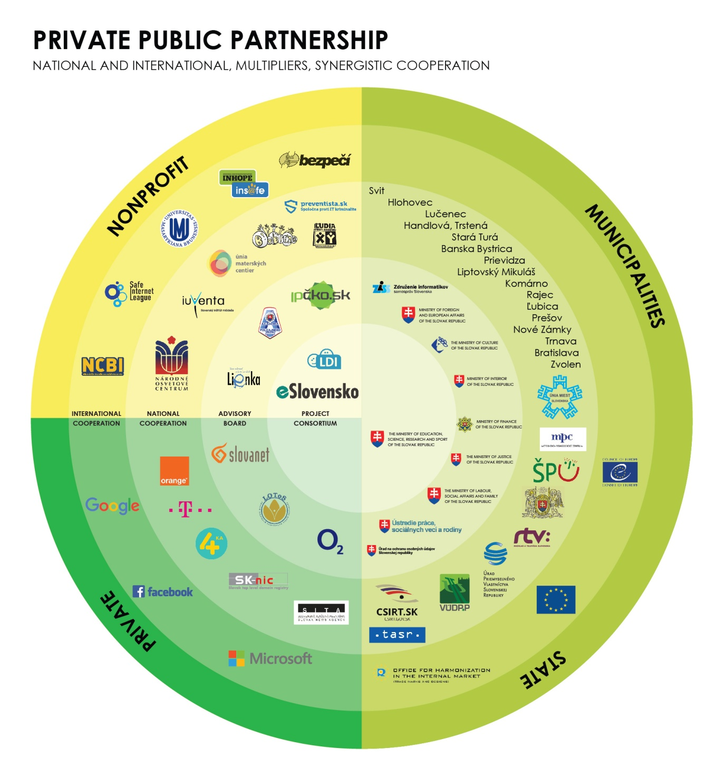
The Advisory Board (88 members) consisted of the representatives of the abovementioned tiers and actors of the society, grouped as follows:
1. state administration bodies and state agencies (ministries of education, interior, labor and social affairs, justice, data protection office, intellectual property rights office, police, pedagogic institutions)
2. local governments (all major towns’ governments within Association of IT Specialists of Local Governments)
3. private entities (ISP, IT companies, social media, media)
4. third sector (non-governmental organizations dealing with child welfare, fight against hate speech and xenophobia, academics)

Amongst the tools used for enhancement of the national cooperation were:
1. Meetings of the Advisory Board and e-mail communication with the members. The meetings took place on 7 September 2015 (in Bratislava), 21 September 2015 (in Bratislava), 5 October 2015 (in Bratislava), 19 February 2016 (in Liptovsky Hradok), 7 April 2016 (in Bratislava), 15 June 2016 (in Bratislava).
2. Participation in the state advisory bodies, such as No Hate Speech Movement under the auspices of the Education Ministry (Meeting at the Education Ministry in Bratislava on 10.6.2016 and 22.8.2016) or The Committee for the Prevention and Elimination of Racism, Xenophobia, Anti-Semitism, and Other Forms of Intolerance (Meeting at the Interior Ministry in Bratislava on 25.5.2015 and 15.6.2016) which lately (July 2016) established a Cyber Crime Multidisciplinary Integrated Expert Group with eSlovensko being a member.
3. Informal communication and participation at the Advisory Board members’ events and events of other stakeholders described within WP 8 Dissemination activities and promotion of the project. List of Advisory Board members:

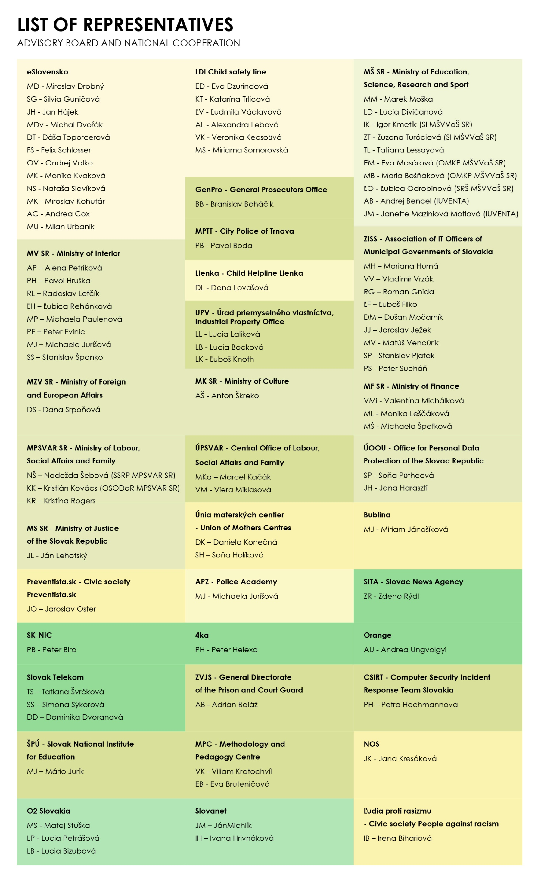
Channels (platforms)
Within the SK SIC action we will extend current project channels and platform with new technologies, i.e. mobile applications and interactive whiteboards (described further below). Besides this new approach applied, SK SIC will keep on redesigning and updating current websites and platforms. In SK SIC IV there will be 8 new channels (platforms) delivered, 4 redesigned. Altogether 25 channels (platforms) will be in operation at the end of the SK SIC action.
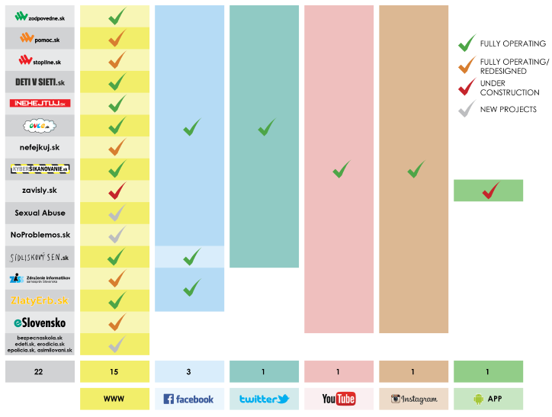
Zodpovedne.sk
MKL platform including SK SIC news, download area (books, guide books for teachers and parents, researches, videos, tools of the Insafe network, annual reports, posters, link to other SK SIC websites, channels etc.), detailed information about online risks and advice how to prevent them, Internet glossary, information about the project, awards, contact information, partners and the AB, tests and interactive games for children. SK SIC will publish also information on key events (such as SID), competitions, inquiry on different topics, etc.

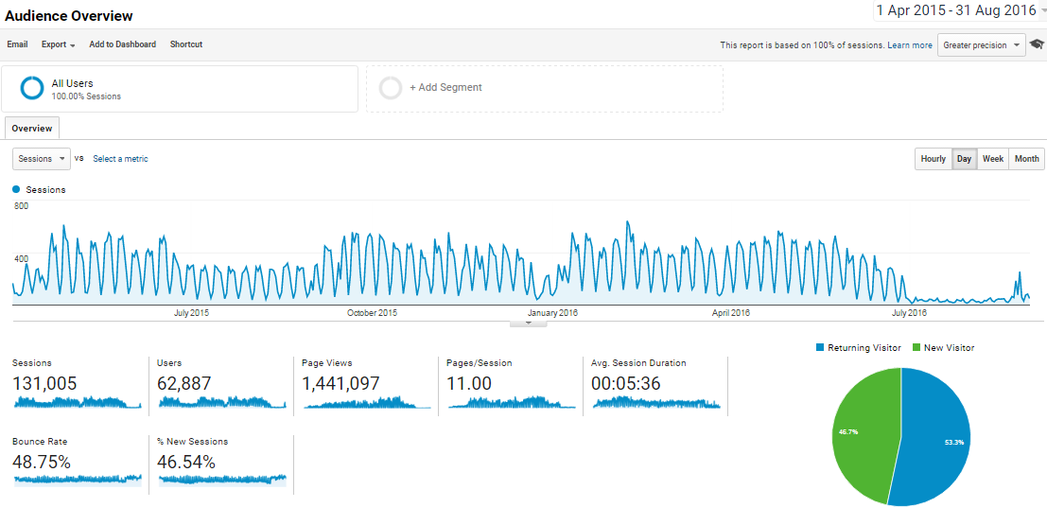
Google Analytics - Zodpovedne.sk

Pomoc.sk
It concentrates the Helpline channels, notably the telephone, email and chat. The domain serves also as a Helpline address via email potrebujem@pomoc.sk, which means “I need help”.
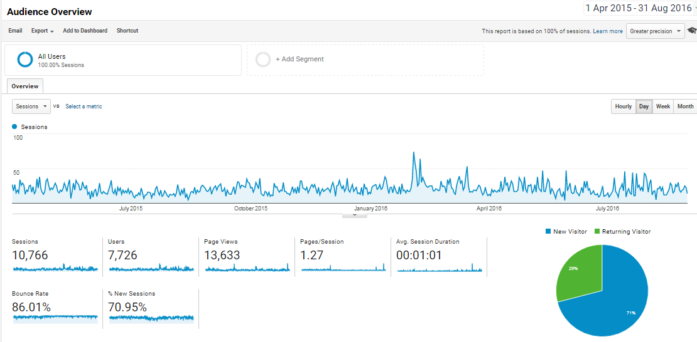
Google Analytics - Pomoc.sk

Stopline.sk
The site includes online form for reporting illegal content and conduct on the internet, information on processing of the report, information about the project, partners, the INHOPE, contains press releases, awards and dictionary of basic Internet terms. Key goal of the national Hotline is to receive information from public relating to illegal content and conduct on the web, operate the web portal Stopline.sk that contains tools designed to help to deal with illegal content and conduct, to fulfil membership obligations of the international network INHOPE, work with know-how of other national centres and organisations from IT sector.
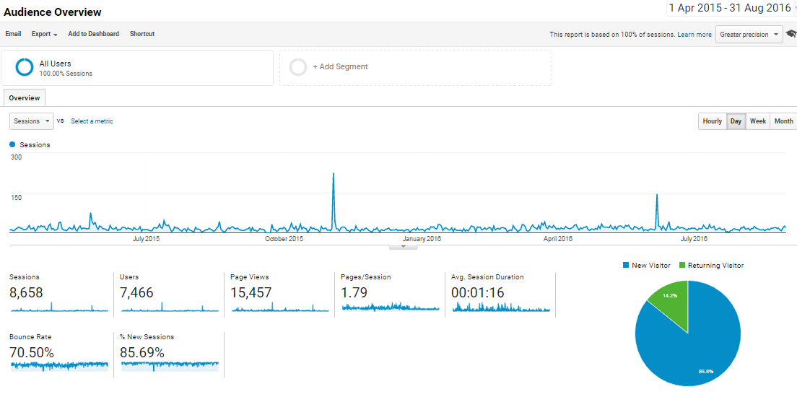
Google Analytics - Stopline.sk

Detivsieti.sk (Children in the web)
The book is core tool and basic element of MKL. Prevention book for the teachers and parents is describing risks and prevention information for beginners and also experienced experts, explaining basic terms with the emphasis on risks, instructions to parents on protection of the children and teens in virtual space.
Main goal of the tool is to increase awareness on risks and their prevention. The book has become the source of knowledge for the prevention describing the risk and its demonstration, explanation of terms. It includes the instructions for parents and teachers, how to protect children and how to talk about the topic and also includes the hints for children and teens. It represents the key source of information for teachers and parents and has become high quality tool for classes as it is the only school book referring to the topic “virtual space” in Slovakia. The book is now used independently and widely in the classrooms and children´s home as well as the official class book within Slovak Curriculum.
First edition of this professional book was delivered and disseminated in February 2012 during the Safer internet day. Original 92 pages gradually expanded to 112 pages in the edition of 2013-14. Recently, we are already working on the 2015-16 edition while adding another topics and issues from the world of virtual threats and protection of children. The website is dedicated to provide target groups with updated version of this professional book and further information.

Nehejtuj.sk
Project Nehejtuj.sk (Donothate in Slovak language) follows intolerance issues. Nehejtuj.sk includes the web portal and the kit including double DVD with 12 professional movies (the goal of the project is to raise awareness within the issues of discrimination, xenophobia and also home violence, i.e. the violence committed on women) and professional book covering as well various intolerance issues.
Website includes tools (videos, the book) dealing with intolerance and hate speech on the internet with the goal to raise awareness within the issues of discrimination, xenophobia, bullying and also home violence.
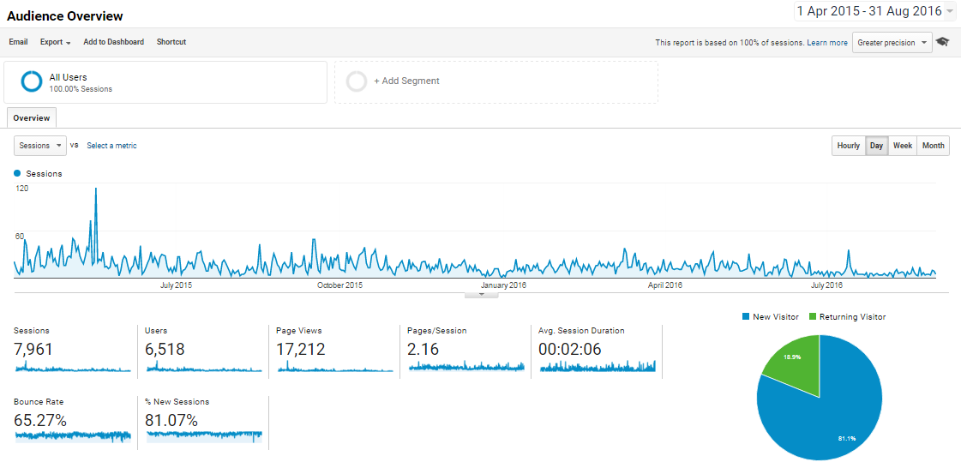
Google Analytics - Nehejtuj.sk
Ovce.sk/Sheeplive.eu
The website is complementary to the Sheeplive cartoons with lots of informative and entertaining content for children. Apart from the videos it offers a handful of accompanying features, such as games, cartoons, glossary, emoticons and many downloadable items. SK SIC has produced Sheeplive cartoons not only in Slovak, but also in Hungarian and Roma, languages of the largest national minorities in Slovakia, version in sign language and version with audio-commentary for blind and visually-impaired audience. Within the SK SIC IV Action there will be developed and disseminated application (represented as an APP in the info- graphic) to be used as a feedback educational tool relating the topics that children and youth met in Sheeplive cartoons (tools). Overview of the Sheeplive tools is part of the info-graphic European and international contribution.
SK SIC Aation will also deliver Sheeplive creative dubbing including new 24 cartoons with creative dubbing, 24 cartoons with no dubbing, 15 online quizzes and education content for interactive whiteboard
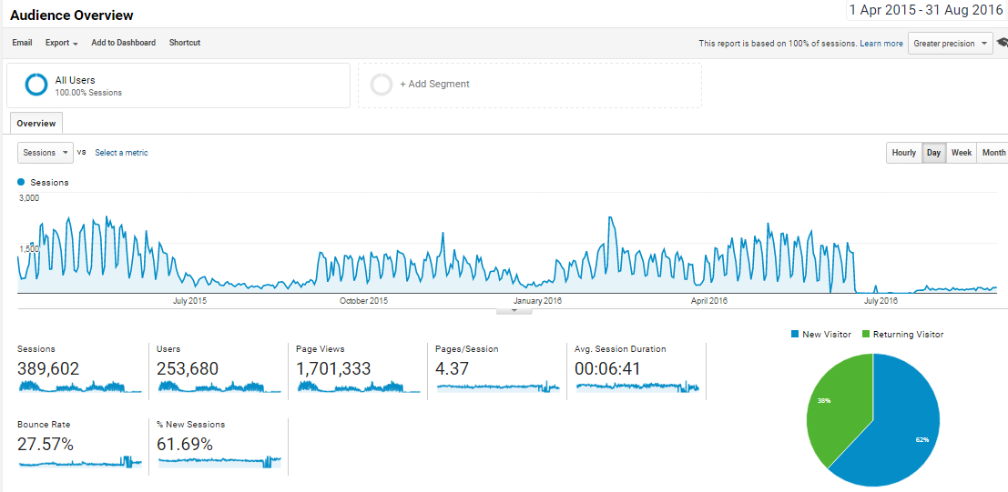
Google Analytics - Ovce.sk/Sheeplive.eu

Kybersikanovanie.sk
Project Kybersikanovanie.sk (Cyberbullying in Slovak language) was launched within the Safer internet day 2015. The educational kit includes the DVD with 6 cyberbullying movies and the professional book (the concept is exactly the same as within the project Nehejtuj.sk that proved off the best impact as for this type of tool). Main goal of the project is to extend children and youth knowledge regarding the topic of cyberbullying and to increase the sensitivity of the topic itself. Project ambition is also to transform passive witnesses into active defenders and guardians especially through the movie emotional experience. Additionally, there is an intention to understand deeply feelings and emotions of victims, aggressors or offenders and the witnesses. Website is dedicated to the project itself with link to other SK SIC websites.
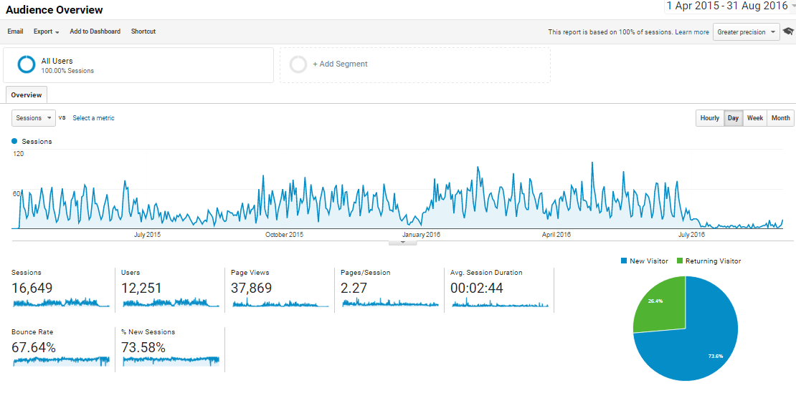
Google Analytics - Kybersikanovanie.sk

Sidliskovysen.sk (RYTMUS sidliskovy sen)
“RYTMUS - dream from the block” is telling the story of famous Roma (gypsy) Slovak rapper named Rytmus. This project follows last 8 years of rapper´s life as he has become sort of hero from zero. The key issues included are hate speech, racism and anti-roma offense (the offence against ethnic/national minorities). The purpose of the movie was to point on and contribute to fight against the hate speech within the roma-racism with online hate speech issues as well. Nowadays, as the movie gained huge success in cinemas, it is broadcasted in the schools in entire Slovakia, also in the Children´s (foster) homes, schools with roma-children as a minority and the prison for youths. There is also the intention to prepare the projection of the movie during the Slovak presidency of EU. Facebook channel has over 27,000 followers (Likes), Youtube teaser with 396,000 views and Youtube trailer with 588,000 views.
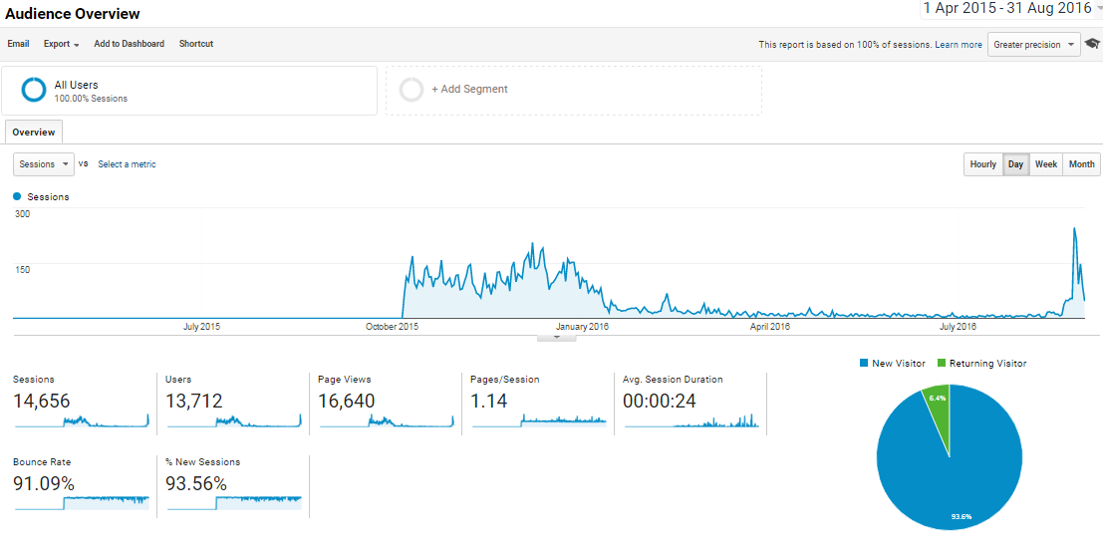
Google Analytics - Sidliskovysen.sk

Other channels (platforms)
SK SIC fully operates three Facebook pages (children, youth and adults), Twitter account, Instagram account and Youtube platform with link to SK SIC (MKL) tools.
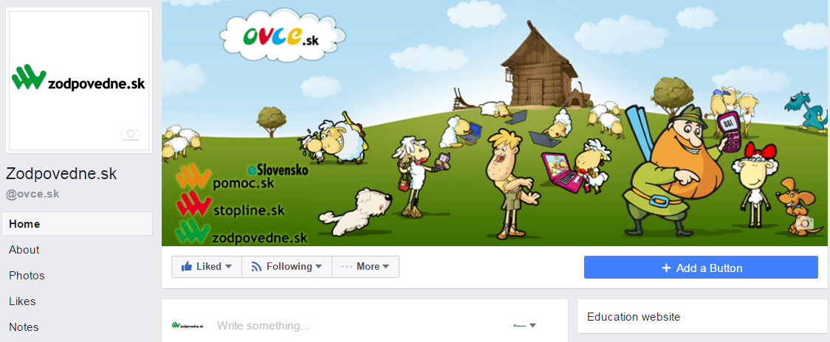
Facebook - Zodpovedne.sk

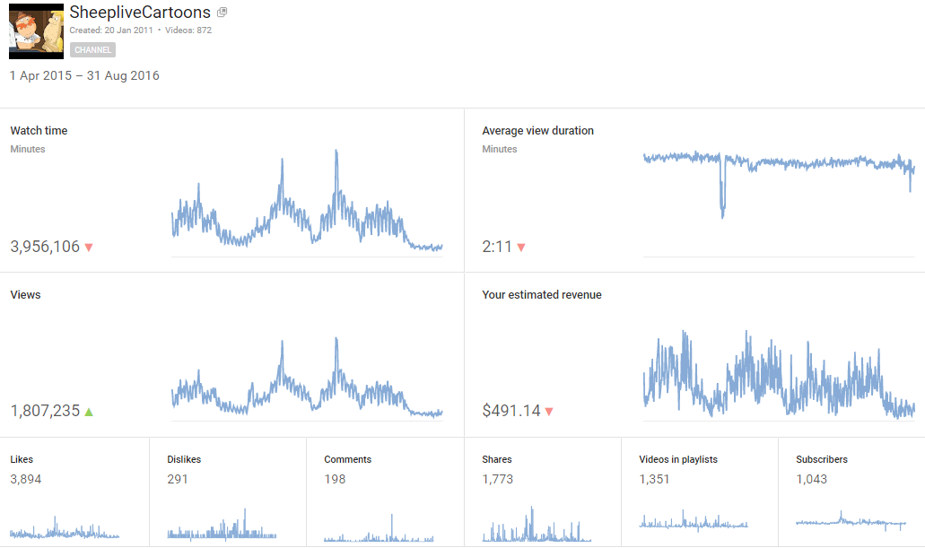
YouTube Analytics – SheepliveCartoons

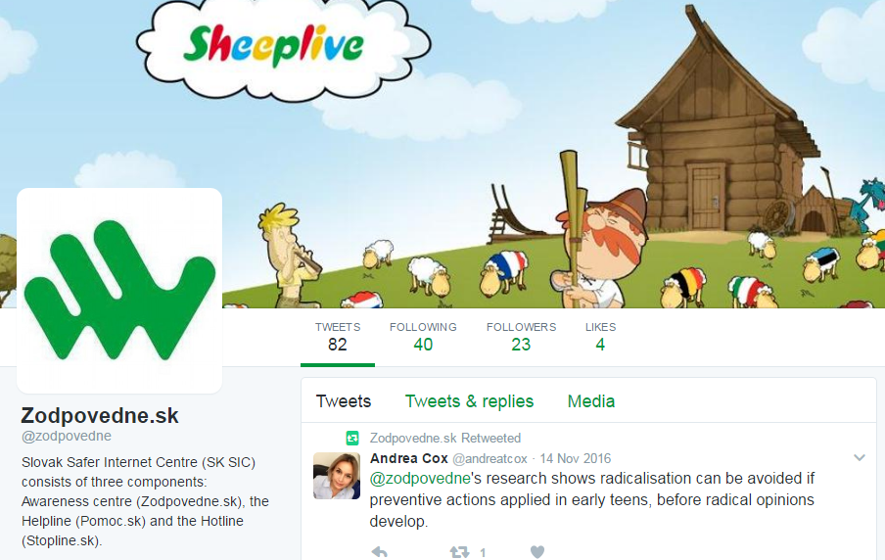
Twitter - Zodpovedne.sk

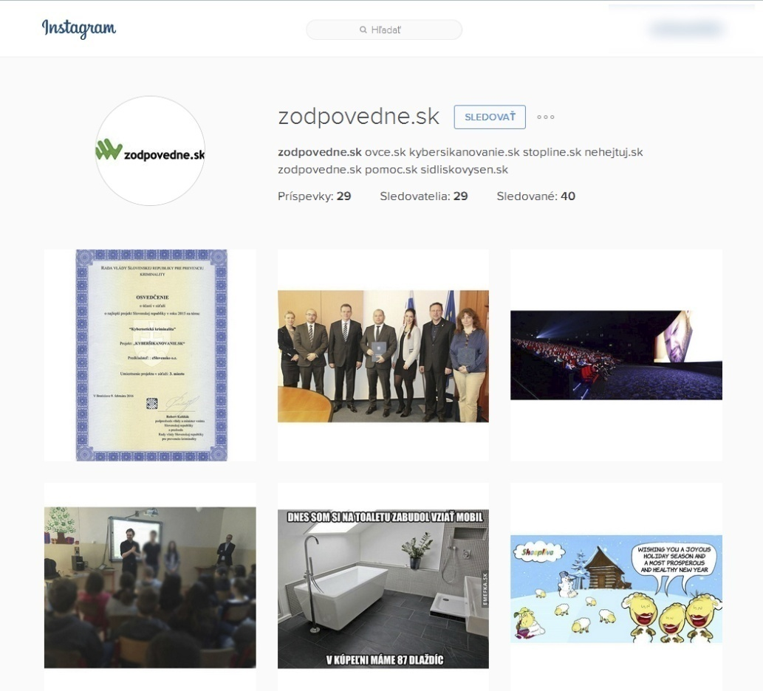
Instagram - Zodpovedne.sk

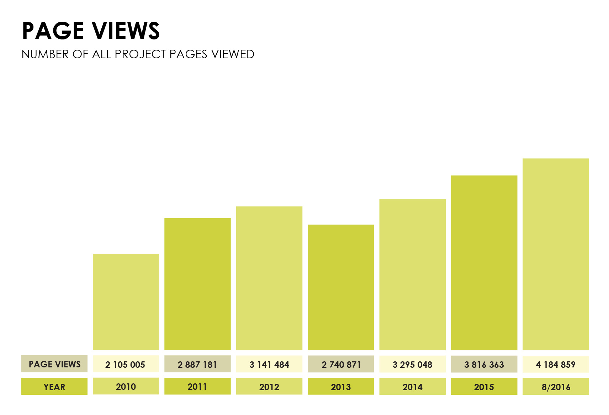
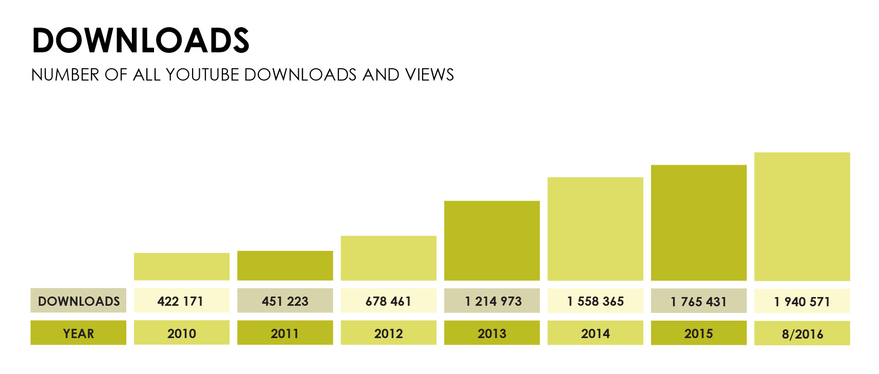
Amongst the most popular, most downloaded and watched are individual cartoons of Sheeplive. Then online tools of Nehejtuj.sk and Kybersikanovanie.sk follow in numbers.

Marketing and media strategy
Marketing strategies and communication campaigns SK SIC are planned to support the strong leading position in the Slovak Republic as evidenced by several prestigious national and international awards. The communication campaign will not pursue only the primary targets, but also builds the brand and its differentiation. Communication is focused not only on the target group, but are also underway with other stakeholders such as partners, shareholders, public authorities, etc. When selecting the channels of communication campaigns are used Above The Line and Below the line) activities. Creative communication strategies contain indicative or transformation challenge. Ambassadors from social, cultural and sporting life are involved through their personal experience to encourage and motivate the target group. By using multimedia elements to a wide communication platform and the latest technology effectively addresses the most demanding audience children and youth.
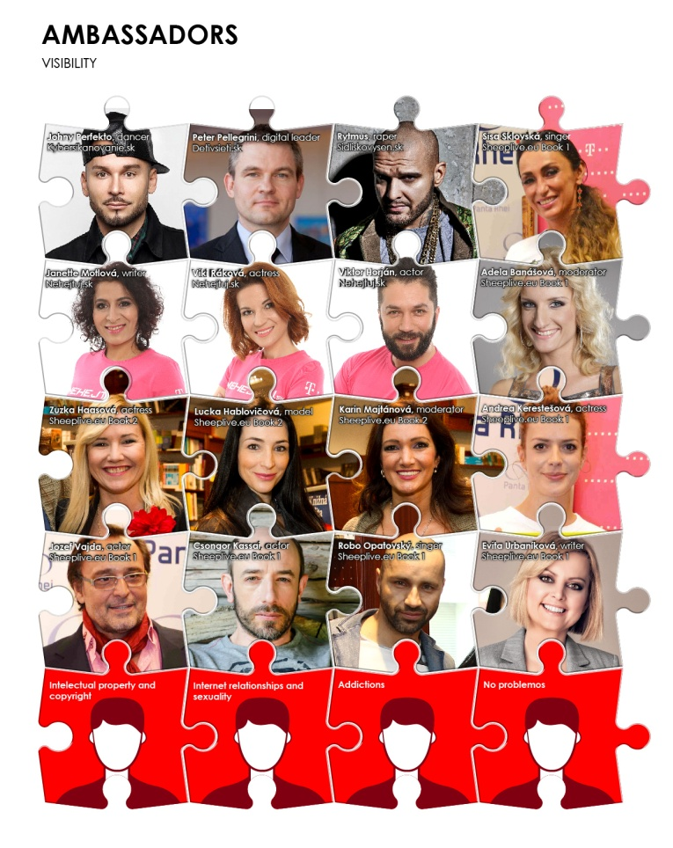
In the Action’s duration a cooperation with the local televisions across whole of Slovakia resulted in 10 TV channels broadcasting the cartoons Sheeplive. It was also broadcast on a national television RTVS (dvojka). Based on the agreement the comics have been offered for free to the Slovak Train Company to be played on screens in the Slovak trains travelling across the country, as well as in the means of public transportation in Bratislava. Billboard and city lights secured promotion of Rytmus Dream from the Block outdoors.
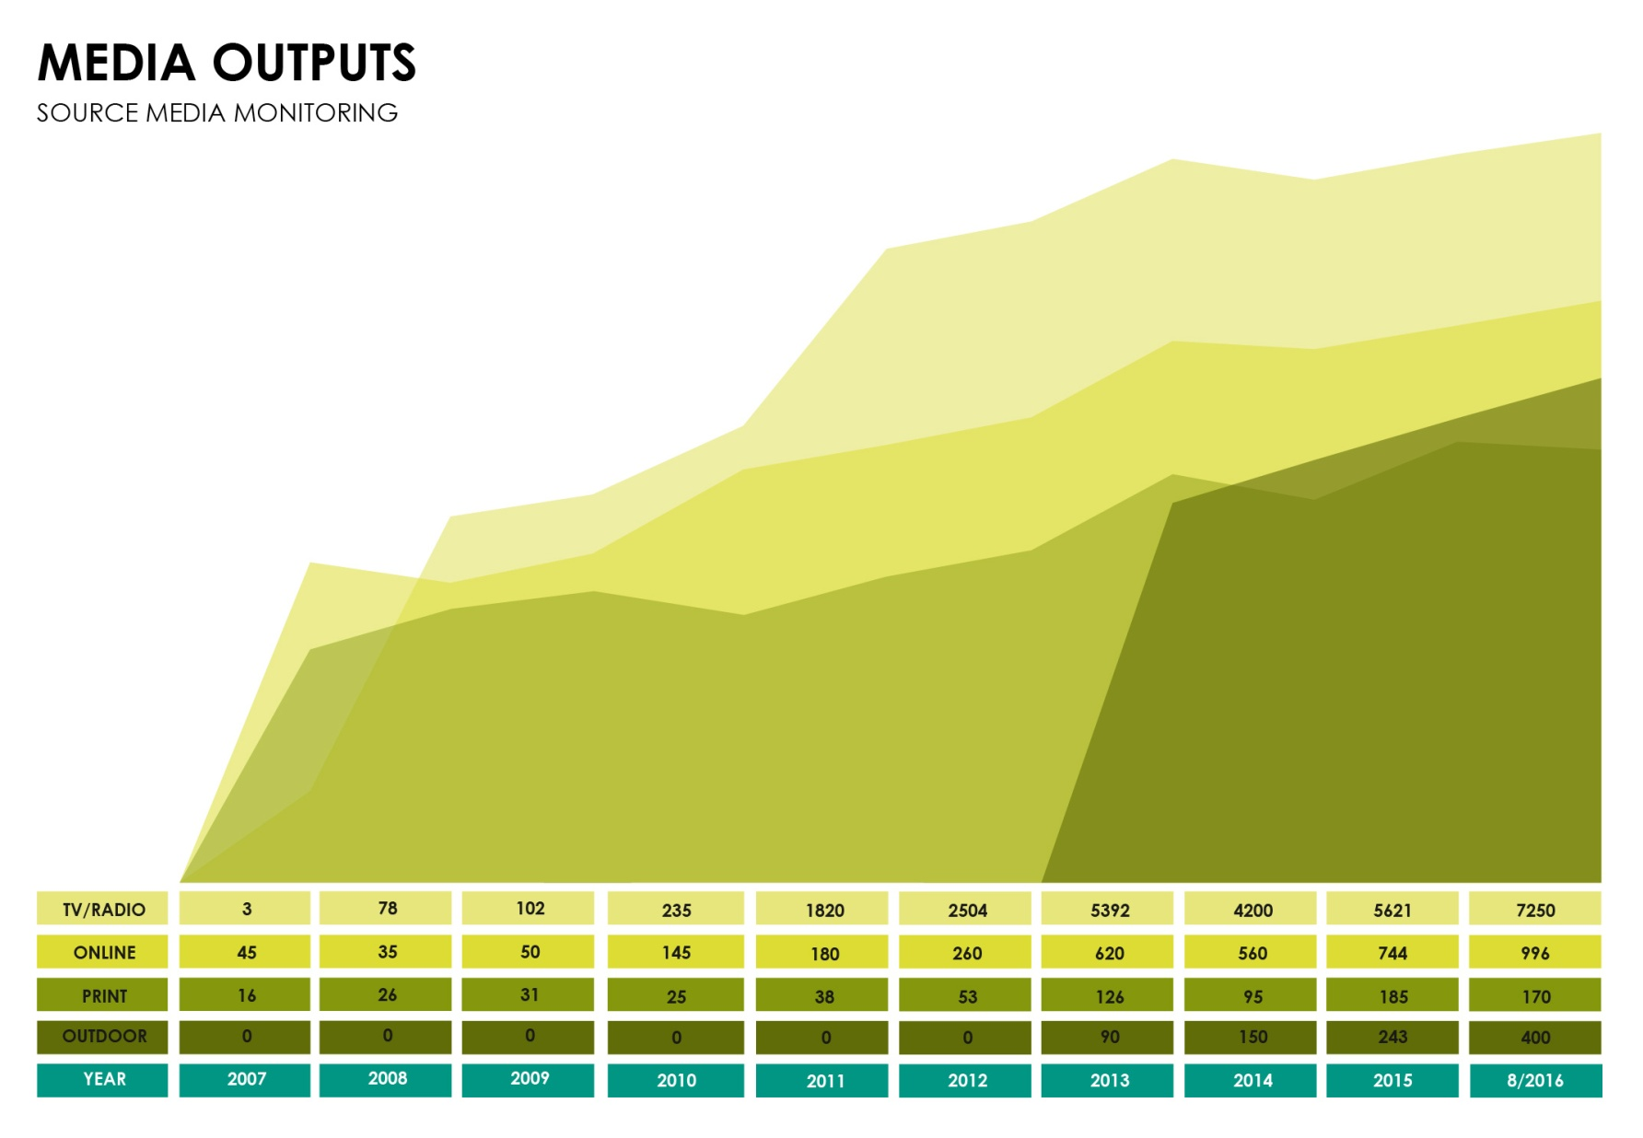
Offline tools
MKL tools including Kybersikanovanie.sk kit, Nehejtuj.sk kit, Sidliskovysen.sk kit, Sheeplive.eu kit, the Children in the web and promotion tools (T-shirts, bracelets I wristbands, stickers, pexeso, posters, bookmarks etc.).

2. HOTLINE Stopline.sk
Hotline operated by the SK SIC is a national platform for combating illegal content on internet. The SK SIC during the course of the action

- Set up and maintained the facility for online reporting of illegal content and/or activity on the internet and new online technologies;
- Updated the manual of procedures in cooperation with law enforcement authorities and in accordance with best practice guidelines; systematic cooperation with law enforcement authorities was developed. The cooperation is fully operational and functional, supported by the Police Cyber Crime Unit with whom communication is established both on the highest and analytical levels;
- Undertook a preliminary assessment of the legality of the content reported, traced its origin and when possible contacted the owner of the reported content with the appeal to take it down;
- Conducted systematic notice to the host service provider of content assessed as illegal child abuse material in accordance with the manual of procedures, monitored and took follow-up action when content was not taken-down rapidly;
- Communication with the ISPs was established;
- Exchanged specific information on identified illegal content with other members in the network;
- Actively informed users of the hotline's remit and how to contact it;
- Recruited, trained and supervised staff;
- Gathered and analysed statistics based on the network template to track performance and establish trends;
- Forwarded all reports on Child Sexual Abuse material (including content hosted in the country where the hotline has its seat) to the European (INHOPE) URL database managed by the network co-ordinator;
- Consulted closely with experts on child sexual abuse issues.
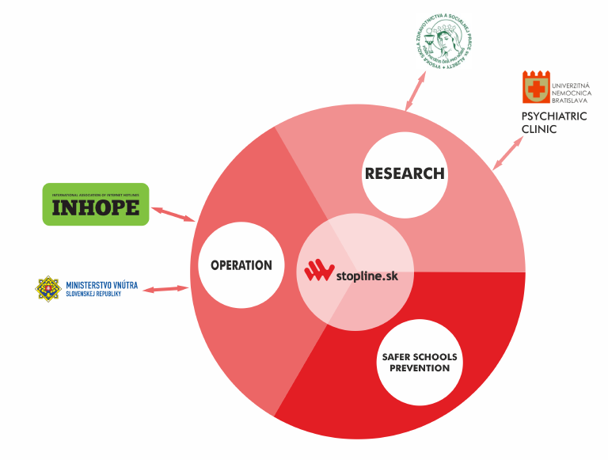
Operation of the Slovak Hotline called Stopline allows members of the public to report illegal content and pass the reports on to the appropriate body for action (Internet Service Provider (ISP), the police or a corresponding hotline). Stopline do not investigate offences or arrest or prosecute offenders. They represent centres of expertise providing guidance to ISPs and other stakeholders as to what content might be illegal in a country. Close cooperation with the national law enforcement agencies has been established as an important element of the hotline operation with the Ministry of Interior of the Slovak Republic (Letter of support enclosed to the Action). Mutual agreement between the Ministry of Interior and SK SIC was signed in 2010. Formal Command of the President of Police Force of Slovak Republic regarding the Release of annual plan of main tasks (Article 5 within the activities of police force in the field of crime prevention by the letter b) ensures tight cooperation with SK SIC on the projects Zodpovedne.sk and Stopline.sk operational work.
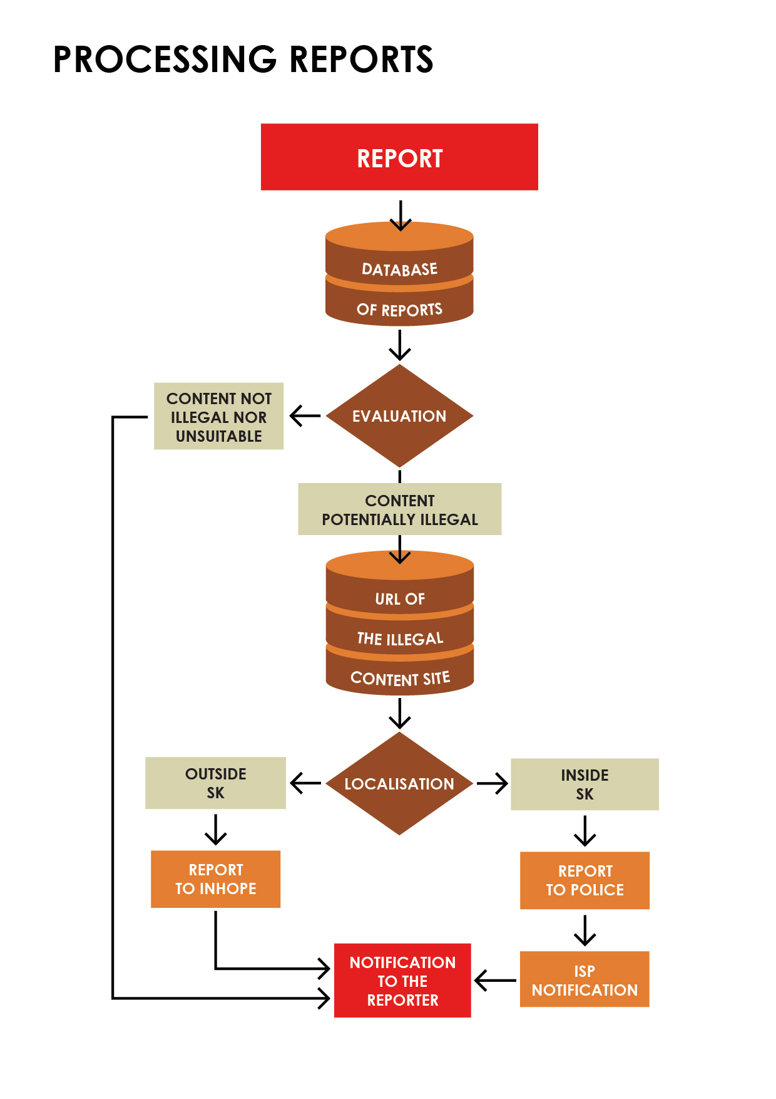
A research on “Forensic and psychological aspects of child sexual abuse” was prepared. The team of 4 was lead by a prominent expert Dušan Kešický. The research was focused on dealing with detection and verification of child sexual abuse, both male and female, aged before 15 as well as homosexual abuse of boys aged before 18. The research focused on integration of knowledge about forensic psychological profile of offenders into the fully-fledged system of knowledge increasing the probability of timely detection as well as verification of suspect cases of child sexual abuse. The team members investigated the problems from the wide perspective of forensic psychological knowledge since child sexual abuse overruns the scope of pedophilia considered as strictly sexual deviation. The significant numbers of offenders who sexually abuse children are not the pedophilic offenders but persons with other disorders. The attention was focused also on the basic research of psychological parameters of offender - victim relationship where positive assumed detection of abuse is typical and often leads to family breakup. The research work focused on ex post facto sources that were provided by experts from their forensic practice. Forensics practice has become an area in which it became urgent need to clarify the terminology in the context of sex offenders against children. At the same time the question arose whether this is not just a matter of terminology, so that there may be substantial differences in the psychological structure of these offenders. Should significant differences in the groups of non-pedophile and pedophile and child abusers be justified, it would mean a real need for disclosure of the mechanisms that lead to crime aimed at the sexuality of children. These relate not only to the detection of criminal activities in forensic-psychological practice, but also with prevention, followed by a possible therapy in the complex process of social reintegration. It would also be a major contribution to the knowledge of epigenetic context giving rise to pedophilia, as well as to changes in the regulatory and control mechanisms which are now failing in suppressing the need of satisfying the sexual instinct non-adaptive and socially unacceptable. Further research and cooperation with the law enforcement and investigators is necessary in order to make a progress in this area with the aim of protection of potential future victims.
Number of reports received during SK SIC III action: 6,237.

3. HELPLINE Pomoc.sk
SK SIC also undertakes to operate national online helplines´ services for reporting and dealing with harmful contact (grooming), conduct (cyberbullying) and content. More specifically, Slovak helpline undertakes to:
- Offer one-to-one conversations, online and on telephone, with trained helpers in real time to give advice and support to parents and children on issues related to their use of online technologies.
- Draw up operating guidelines in compliance with national law, including data protection rules
- Ensure that reporting mechanisms are interoperable both with the core platform and with reporting via service providers such as Social Networking Services.
- Provide qualitative and quantitative feedback at European level through the core service platform.
Action SK SIC implements already established Helplines cooperation network involving key national organizations operating within Slovakia to ensure the coverage of children/youth/parents advisory and support in entire country. While involving organisations with wider and extended range of advisory issues, SK SIC IV project will bring complex advisory services for project target groups with high level of know-how transfer and best-practices change on national and also european/international level (as demonstrated in info-graphic)
Members of Helplines cooperation network
Helpline eSlovensko Bratislava
eSlovensko acts as Helpline network coordinator and network representative since 2007 (part of the Insafe network. Within the SK SIC, eSlovensko is operating the Helpline counselling online (primarily e-mail).
Key tasks of eSlovensko:
- provide advisory within the safe internet and modern technologies use while contributing to project figure database and evaluation processes,
- elaboration of helpline operational manual,
- attending Advisory board meetings, SK SIC´s events, actively collaborate on SK SIC´s tools development.

Children safety line (Linka detskej istoty; LDI)
Slovak Committee for UNICEF (SC UNICEF) has established non-profit organization Linka detskej istoty (Child safety line) dedicated solely to the implementation of the project SK SIC under the programme Connecting Europe Facility. Child safety line has been operating for 19 years. Activities of Child safety line are based on the basic philosophy and mission of the UNICEF world organisation, i.e. protection, support and adherence to children rights in line with the Children Rights Convention. At the same time, it is a member of international organisations whose interest focuses on children. Since 2004 SC UNICEF is the member of the Child Helpline International, network of helplines from the whole world. Involved in SK SIC since 2007. Since 2008 it has been the line member of the international organisation Missing Children Europe. Currently, with its range of the provided distant services it represents the only line in Slovakia which respects and fulfils the set of international standards for child lines. These standards include non- stop operation, access from all parts of Slovakia, anonymity, free of charge and existence of the expert supervision.
The Line has started its operation under the unified number 116 111 on 1st October 2008. It offers up to 20,000 children yearly the space for communication provides psychological, social and legal advice, adequate information, and crisis prevention in difficult life situations and arranges follow-up interventions. Key tasks of Children Safe Line:
operating Child Line for general problems (116 111) with main goal to secure the first contact and offer expert assistance and care. If necessary, it would arrange adequate special help according to the location of the child,
- Internet Line has been available already since 2001 - covering needs of the electronic media era.
Special communication and counselling via www.ldi.sk and via www.unicef.sk. Since 2007 a special line has been operating - Pomoc.sk, which pays more attention to the issues of the virtual world and new technologies and their impact on children. It uses 3 channels – nonstop telephone line via the number 116111, the email address potrebujem@pomoc.sk and online chat,
- line for missing and sexually abused children - 116 000 – provides a possibility to call and search advice or help for children out of home by force or voluntarily. It offers counselling and information also to parents, giving them the possibility to consult their procedures and approaches in case, they children have not returned home,
- Parent’s Line – created for parents to consult their educational procedures, gain information and together with experts look for the best solutions when having problems with their children.
The line pays extra attention to excluded children (socially or physically), as well as children of minorities (Hungarian, Romanian). The quality of work of all parts of Helpline is secured via the expert potential of the team of consultants and supervisors. The first contact has been secured by university students after receiving psychological, social and communication training from distance counselling. Further specialist’s interventions are being provided by supervisors – experienced experts in the area of psychology, social work, pedagogy, law, with at least of 10 years of experience in the given field.

Society of friends of children - Lie(e)nka Spoločnosť priateľov detí
Established as a non-profit organization whose primary mission is to help children who are at risk of violence or other forms of social pathology. It aims to inform children and the general public about the possibilities of protection against violence, increase their sensitivity to this phenomenon, explains and promotes the rights of children. Child Line Li(e)nka is a free helpline for children established in 1999. In 2011, Child line Li(e)nka launched the Internet telephone contact clinic while adding e-mail advisory channel and Skype support also. Child line is to be found on Facebook as well. Child line will be involved in SK SIC from 2014. Key tasks within the SK SIC project:
- prevent unwanted social phenomena, such as aggression towards children and among children, drug and other addictions, suicidal actions and also emotional and psychosomatic disorders,
- provide information on the physiological maturation and sexual issues, including contraception, sexually transmitted diseases, as well as facts about drugs of addiction and the like,
- provide assistance and crisis intervention for children at risk of violence, or other emergency situations,
- provide emotional support, to allow ventilation problems and thereby prevent the occurrence of emotional and psychosomatic disorders, drug addiction, crime and suicide case,
- offer information about how the child can defend themselves against violence, what are their rights and where they can seek help, mediate direct contact with other professionals,
- provide children with a more human communication,
- provide advisory within the safe internet and modern technologies use while contributing to project figure database and evaluation processes, elaboration of helpline operational manual, attending Advisory board meetings, SK SIC´s events, actively collaborate on SK SIC´s tools development.
Number of online/phone call cases received during SK SIC III action: 1,993.

4. Monitoring, evaluation and awards
The SK SIC kept on monitoring its performance and alongside providing the online assessment reports for helpline and hotline, it focused also on getting feedback from the target groups.
It performed evaluation of the impact of its main activities, 3 feedbacks (for the following campaigns Do not hate, Cyberbullying, Rytmus Dream from the Block), 3 pre-research feedbacks (for Cyberbullying, eAddictions and NoProblemos) and quality assessment “Quality assessment of the selected projects implemented by Slovak Safer Internet Centre in 2015 – 2016”. Apart from that monitoring of media impact has been executed daily, implemented by an independent entity Slovakia Online. Important source of the monitoring was the social media operated by the SK SIC. 6 meetings of the Advisory Board and those of the Youth Panel provided a good quality feedback. The SK SIC participated at several competitions with their awareness raising activities and campaigns and got several awards:
- 2016 3rd place in the Cyber Crime Competition of the best projects of the Slovak Republic in 2015
- 2015 1st place in the national round of the European Crime Prevention Award - ECPA 2014, Slovensko
- 2015 “Slovakia without barriers” award in category Barrier free intermedia project for Rytmus Dream from the Block
- 2015 Special prize for the president of eSlovensko for outstanding contribution in IT field in the Slovak Republic
- 2015 Movie award for the 2nd place at premiere weekend in theatres in the Slovak Republic for Rytmus Dream from the Block in the history of Slovak cinematography
- 2015 Movie award for the highest ever attendance at a Slovak film on the first day in theatres in the Slovak Republic for Rytmus Dream from the Block in the history of Slovak cinematography

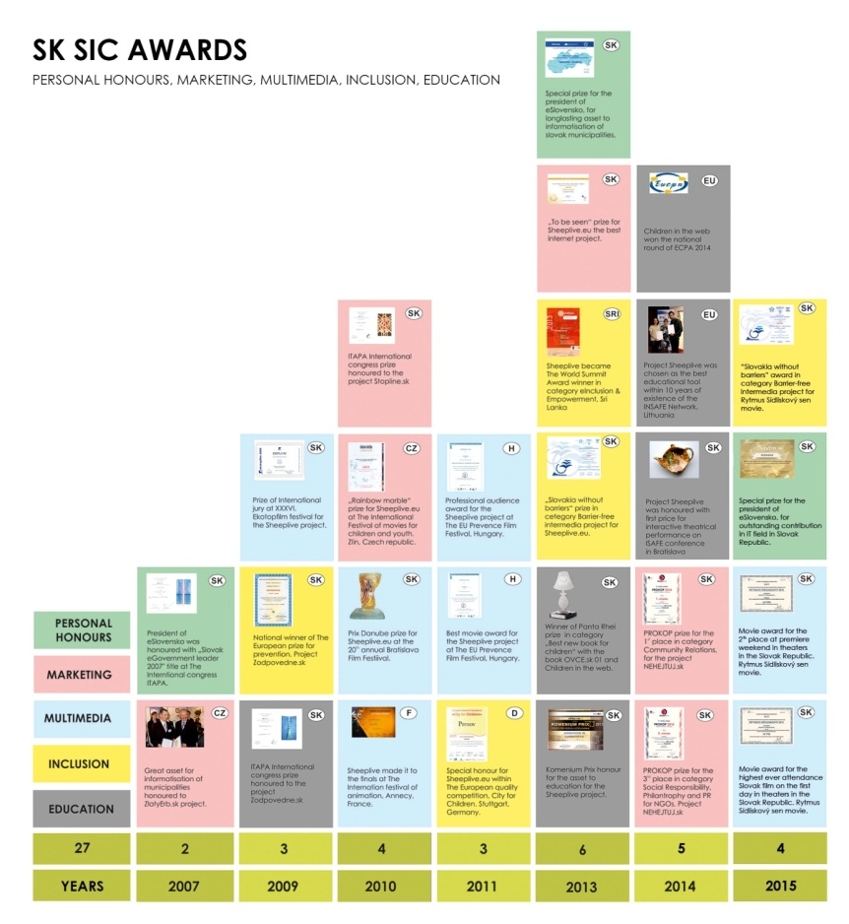

Feedback to the film Rytmus Dream from the Block
An excerpt from the collecting feedback to the film Rytmus Dream from the Block, which was used as a multi genre tool to sensitivise youth to stop cyberbullying and prevent racism and antiziganism, brings the main conclusions hereby. A questionnaire was prepared and sent out to all schools, re-correction centres, children homes and other institutions whose clients (children) saw the film. It was answered by 1 084 respondents from communities from all over Slovakia with an average age of 15.4 years, 95% of respondents in the age range of 13-18 years. 7th to 9th years of elementary school and 1st to 3rd years of secondary school students were involved. A quarter (25.9%) of Slovak teenagers aged 12 to 20 years saw the film Rytmus Dream from the Block and still more are about to. The results showed that most teens (83.6%) who saw it liked it. Out of this number 53.6% of teens indicated that they liked it a lot.
Those respondents who are more conciliatory towards the Roma, liked the film the most and on contrary those who occupy the position of extreme distance towards the Roma liked it least. This result is statistically significant. Attitudes are sometimes stable in the long term, it is difficult to change them, without anything substantial man came to the attention, especially own experience. Based on the survey it can be said that up to 42.4% of teenagers said that thanks to the film they improved their attitude towards Roma.
The greatest improvement in attitudes towards Roma after having watched the film Rytmus Dream from the Block is reported by those who are generally more tolerant, i.e. most of the Slovak teenagers. Those distancing themselves considerably from Roma report the minor changes in their attitude for the better. Those who do not wish to live with the Roma people in one country report the least change of attitude. 64% of teens after watching the film feel better about themselves and their families.
This improvement occurred in a significantly higher proportion of viewers who do not distance themselves from the Roma extremely. 70.4% of those who saw the film then reflected upon what is important for them in life. Those with extreme attitudes towards Roma after watching the film pondered their priorities significantly less than those who are more tolerant towards Roma.
The project Rytmus Dream from the Block as a means of prevention puts, through a life story, the importance of getting to know and accepting one's roots, Roma identity and pitfalls associated with it, but also the possibility of successful acceptance. In addition to the line of the film about the process of personal transformation, viewers can perceive the present line of social norms, expectations and stereotypes.
The research confirmed that the film viewers liked the film and that it is useful as a stimulus for discussion, reflection on life priorities, treat their own self-image when working with the youth. Approaching a personal story of a Roma boy growing up in a non-Roma family improves attitude of the viewers towards the minority. The research confirmed that the film Rytmus Dream from the Block is a significantly more effective prevention tool for the majority (73.3%) of teenagers, general population and those growing up in a risk prone environment, but is a less useful tool for working with those who are already intolerant towards the minority.
Quality assessment of selected projects implemented by SK SIC in 2015 – 2016
The SK SIC also had a qualitative evaluation of its select activities performed. The evaluation was done by an independent expert Nataša Slavíková who is a media literacy expert. Ms Slavíková was a representative of the Slovak Republic in the European Commission’s task force for media literacy (2011 – 2014), senior expert and top manager in state administration bodies (Media, audiovisual broadcasting and copyright unit, Ministry of Culture of the Slovak Republic (2007 – 2012), Office of the Slovak Republic’s Committee for Audiovisual Broadcasting (1993 – 2000). She is a founder of the Slovak Audiovisual Fund. Ms Slavíková tutored creation of the national Concept for life-long media education, approved by the Slovak government in 2009, as well as altogether seven national enactments regarding the media. She initiated mandatory age labelling of televised programmes in the Slovak Republic, participated in national project of the Slovak Ministry of Education, Science, Research and Sports entitled Activation Methods in the role of tutor of integration of media education in schools and educational facilities (2013 – 2015) and authored seven tutorials on the integration of media education in schools and educational institutions (2015). As a research fellow, later Deputy secretary general was responsible for analyses and public relations in the National Centre for Education and Teaching (2012 – 2015).
The qualitative evaluation states that the SK SIC’s projects successfully showed how to utilize in an attractive manner theoretical knowledge, studies and surveys not just in informal but also in the formal education in schools and school facilities with focus on the age-differentiated formation of positive attitudes and values. Implementation of the projects shows how to actively involve children and students in the process of raising their internet literacy and what methods should be used for motivation of children to become more capable to lead reasonable life on the internet and behave responsibly and not succumb to manipulation. In the digital world, everyone leaves a digital trail that accompanies them through life, so one needs to act responsibly.
The main objectives of the selected projects of the SK SIC in the reporting period 2015 and 2016 were met and in many ways exceeded. The projects were topical, comprehensive, freely available, widely accessible and applicable. The analysis stressed the high quality of their implementation and positive social and educational benefits in terms of:
- raising of the level of protection of children and young people in cyberspace and their positive socialization and support to social inclusion
- increasing of the level of internet literacy in formal and non-formal education,
- promoting of culture of tolerance in real and virtual space,
- raising of the copyright awareness,
- raising of quality of media education and media literacy in school and school facilities.
- The evaluator further concludes that the SK SIC
- improved quality and availability of quality education in the sphere of Internet literacy; with emphasis on promoting critical understanding of internet content, values education and formation of positive attitudes;
- continually updated its special learning aids, methodologies, comics, movies, web portals;
- systematically provided advice and consultation for children and youth in the sphere of internet threats;
- linked intensively formal and informal learning using various media platforms, applications and web portals, focusing on raising the level of internet literacy;
- created multimedia library, new media portals, published and otherwise made available project results (such as surveys, studies, analyses, free tutorials, methodologies, audiovisual content, interactive teaching aids and manuals) to the wider educational community in order to secure project's lasting relevance;
- created background for the implementation of prevention policy of the Slovak Republic which creates an inseparable part of the security policy of the Slovak Republic, which aims to achieve control of crime by coordinating complementary set of repressive and non-repressive means. It dealt with the procedures for reducing the occurrence of socio-pathological phenomena, motifs and opportunities to commit crimes.
- It is important to take into account the recommendations of the evaluation’s author that the SK SIC is to
- ensure continuation of the SK SIC’s activities and expand its activities towards current social challenges and the ever increasing internet threats
- consistently inform legislators, policymakers and the government bodies involved of current trends and solutions from the area of the SK SIC’s interest, and intensify mutual communication.
- increase visibility of the SK SIC’s activities towards the key players of industry and public authorities in order to ensure the perspective of long-term relevance and sustainability of the SK SIC’s activities, and maximize the impact on target groups.
- maintain active relationships with the media and groups that can help with dissemination of outputs contained in the multimedia library.
- continue with the activities aimed at integration of Internet literacy into education by means of activating methods, incorporated therein either as single theme, or in form of cross-cutting themes, and that in schools and educational facilities, and also in the context of lifelong learning.

